|  |
| --- |
| Computing Technology Inquiry Project |
| Assignment 1 Report  COS10026  Terence Wong Chin Seng| 104404059 |
| Bachelor of Computer Science (Honours) |
|  |
|  |

School of Engineering, Computer Science

Swinburne University of Technology

Sarawak Campus

# TABLE OF CONTENTS

TABLE OF CONTENTS 1

1.0 Introduction 4

2.0 Website Content 5

2.1 Sitemap 5

2.2 Index Page (Main Page) 5

2.2.1 Overview 5

2.2.2 Navigation Bar 6

2.2.3 Shopping Cart 6

2.2.4 Product Preview Carousel 8

2.2.5 Membership Section 9

2.2.6 Latest News & Promotion 11

2.2.7 Location & Store Information 12

2.2.8 Video Section 13

2.2.9 Footer 14

2.3 Products Page (Menu Page) 15

2.3.1 Products 1-4 17

2.4 Blog (Activities & Event Page) 18

2.4.1 Current Activities Page 20

2.4.2 Coming Soon Page 20

2.4.3 Past Activities Page 21

2.5 Form Pages (Join Us, Enquiry, Registration, Login Pages) 22

2.5.1 Join Us 22

2.5.2 Enquiry 23

2.5.3 Registration 24

2.5.4 Login 25

2.6 Profile Page 26

2.7 Enhancements 28

3.0 Website Style 30

3.1 Index Page Styling (Main Page) 30

3.1.1 Navbar & Cart Icon + Sidebar 30

3.1.2 Hero Section 32

3.1.3 Product Preview Carousel 33

3.1.4 Membership Section 35

3.1.5 Latest News and Promotion 37

3.1.6 Location & Store Information 38

3.1.7 Video Section 39

3.1.8 Footer 40

3.2 Products 41

3.2.1 Drink Name Section (.prd-drink-name) 42

3.2.2 Category Toggle Section (.prd-toggle-wrapper, .prd-menu-toggle, .prd-menu-btn, .prd-menu) 42

3.2.3 Product Grid Section (.prd-content-container, .prd-product-list, .prd-product-item) 42

3.2.4 Drink Info Block (.prd-name, .prd-description, .prd-price) 43

3.2.5 Full Table Menu (.full-menu, .menu-table, .menu-table-wrapper, .prd-menu-category) 43

3.2.6 Product Explainer (.product-explainer) 43

3.3 Blog (Activities & Event Pages) 44

3.3.1 Blog 44

3.3.2 Coming Soon 45

3.3.3 Current Activity 46

3.3.4 Past Activity 47

3.4 Join Us & Enquiry 48

3.5 Membership 50

3.6 Login 52

3.7 Profile Page 53

3.8 Enhancements 55

4.0 Key Features (Enhancements) 57

4.1 Navbar 57

4.2 Shopping Cart 57

4.3 Mobile View 58

4.4 Footer 59

4.5 Carousel Section 59

4.6 Membership Flip Cards 60

4.7 Interactive Map 61

4.8 Looping Videos 61

4.9 Category Sidebar Hover 62

4.10 Slideshow 62

4.11 Blog Hover Effects 63

4.12 Profile Page Cards 64

5.0 Conclusion 65

5.1 Future Improvements and Recommendations: 65

# Introduction

The *Brew & Go* website was developed as a marketing-oriented platform with two core objectives: to act as a digital storefront that promotes the brand and its offerings, and to provide existing and potential customers with an engaging and informative user experience. It serves both as a presentation tool for marketing purposes and as a self-introduction for the Brew & Go brand.

For existing customers, the site allows members to sign in, browse the latest drinks and promotions, collect points, and stay updated with current activities and events. For new visitors, it introduces the brand’s identity, culture, and product philosophy in an accessible and visually appealing format.

This project holds deep personal meaning to us. It represents the most time, energy, and creative effort We’ve ever invested in any assignment so far. From structuring the content and developing forms to fine-tuning the CSS animations and layout details — every line of code reflects hours of dedication. While I acknowledge that the submission deadline marks the current limit, I view this site as one of my most complete and polished works to date.

This report will provide a breakdown of the website’s structure and purpose, an overview of the design and styling techniques used, and a review of the key features and enhancements implemented throughout the project.

# Website Content

## Sitemap

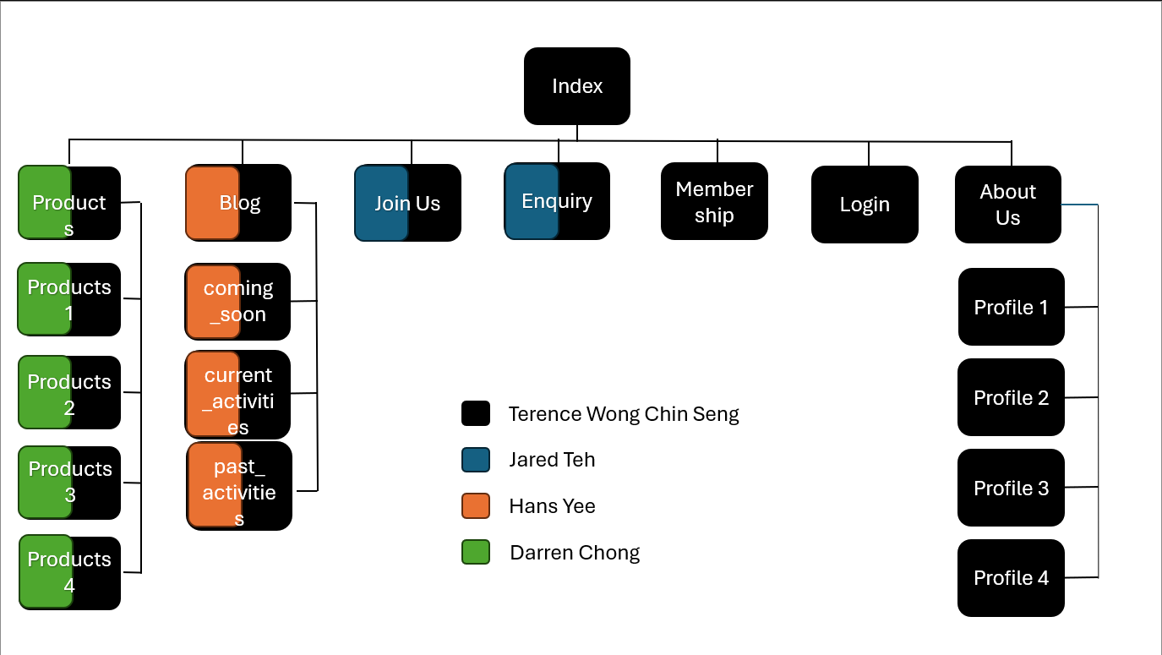

## Index Page (Main Page)

### Overview

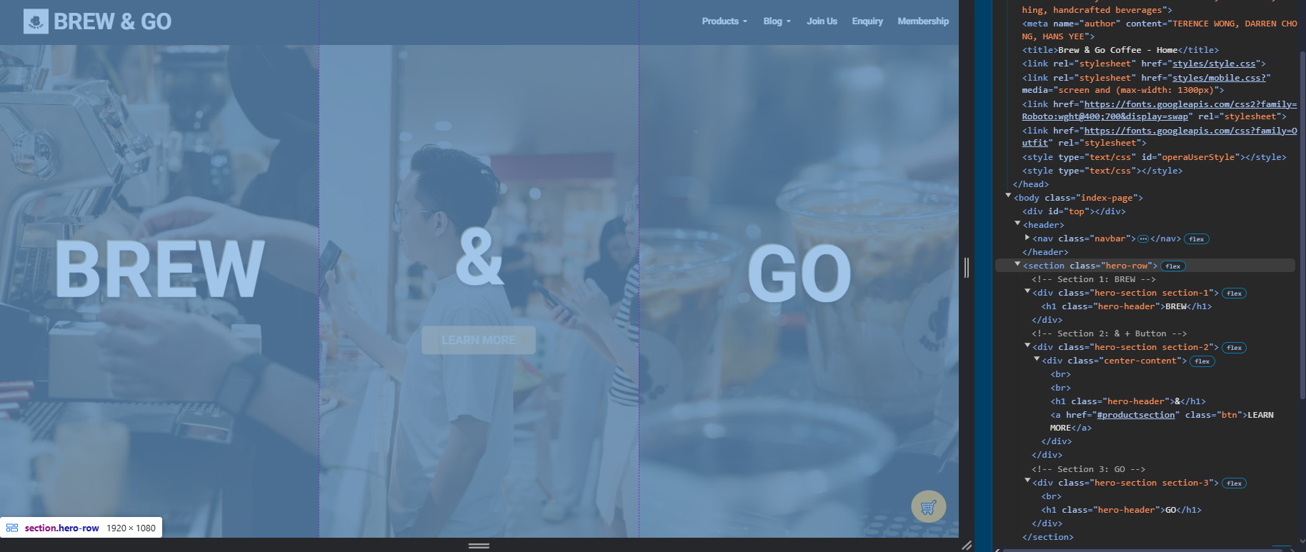

This is the homepage and the first touchpoint for visitors. It introduces the Brew & Go brand, includes an animated hero section, showcases featured drinks via a horizontal carousel, and promotes upcoming activities, membership perks, and store locations. The structure is divided into multiple <section> tags to separate visual elements and improve readability.

### Navigation Bar

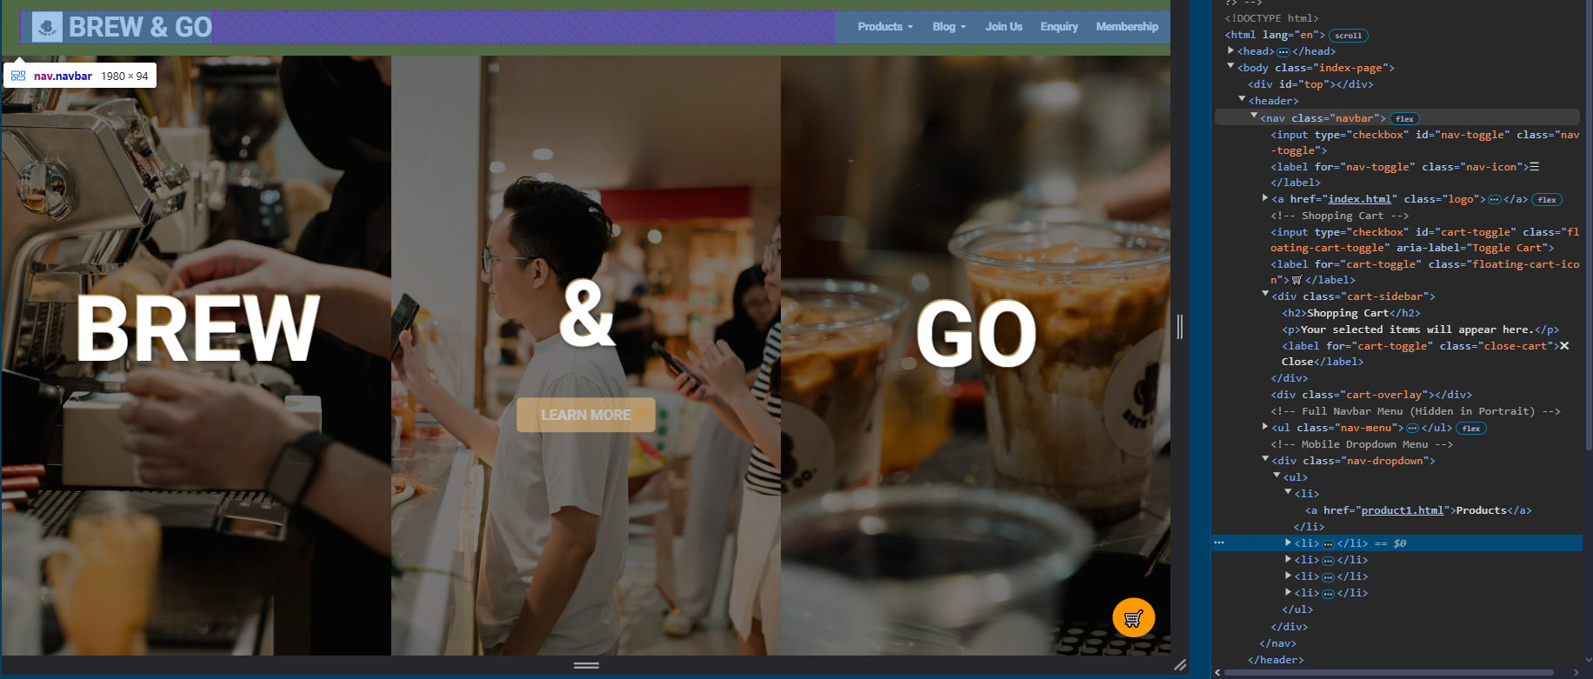

A fixed, black-themed navbar stretches across the top of the page. It includes clear navigation links: **Products**, **Blog**, **Join Us**, **Enquiry**, and **Membership**. The **Products** and **Blog** sections are dropdown-enabled using semantic <ul> and <li> elements for accessibility.

### Shopping Cart

On the right-hand side is a floating **shopping cart toggle icon (🛒)**, the orange circular cart icon remains pinned to the bottom-right of the screen. accessible from all pages. Clicking the cart expands a sidebar with item previews, even across page transitions. Implemented using a checkbox input for toggling and pure HTML/CSS without JavaScript.

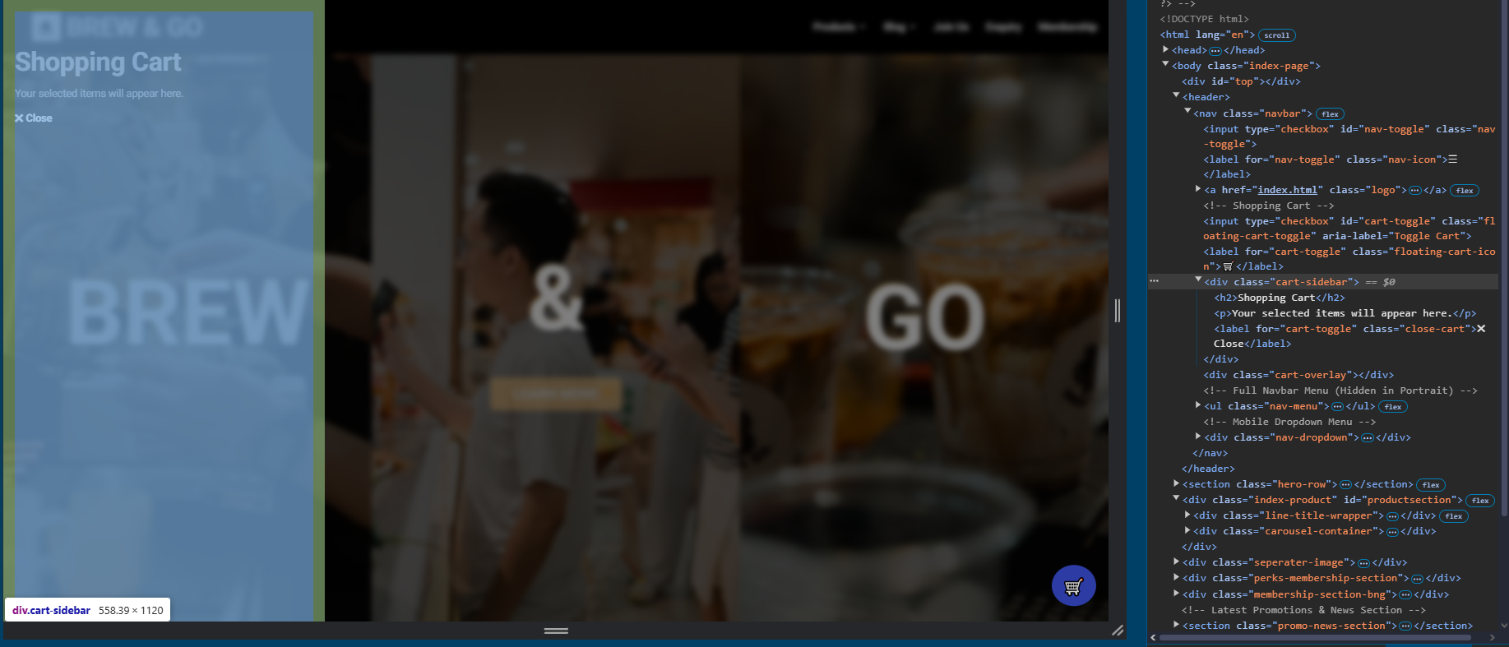

This feature is implemented using a <input type="checkbox"> element paired with custom CSS styling — no JavaScript was used in the process. While this cart does not currently support item selection or checkout (as the functional backend is not part of Assignment 1), its structural integration ensures a seamless **user experience** and anticipation of future functionality, mobile-friendly, **responsive toggle design** and clear visual feedback with <label> targeting <input> to simulate toggling interaction.

This ensures that the user can **always access their cart** regardless of where they are on the site — from product pages to the Join Us form — ensuring functional consistency and professional UX flow.

The cart system showcases readiness for **backend integration** (PHP, database, and session state) in Assignment 2 — where real cart items, quantity tracking, and checkout workflow will be implemented.

### Product Preview Carousel

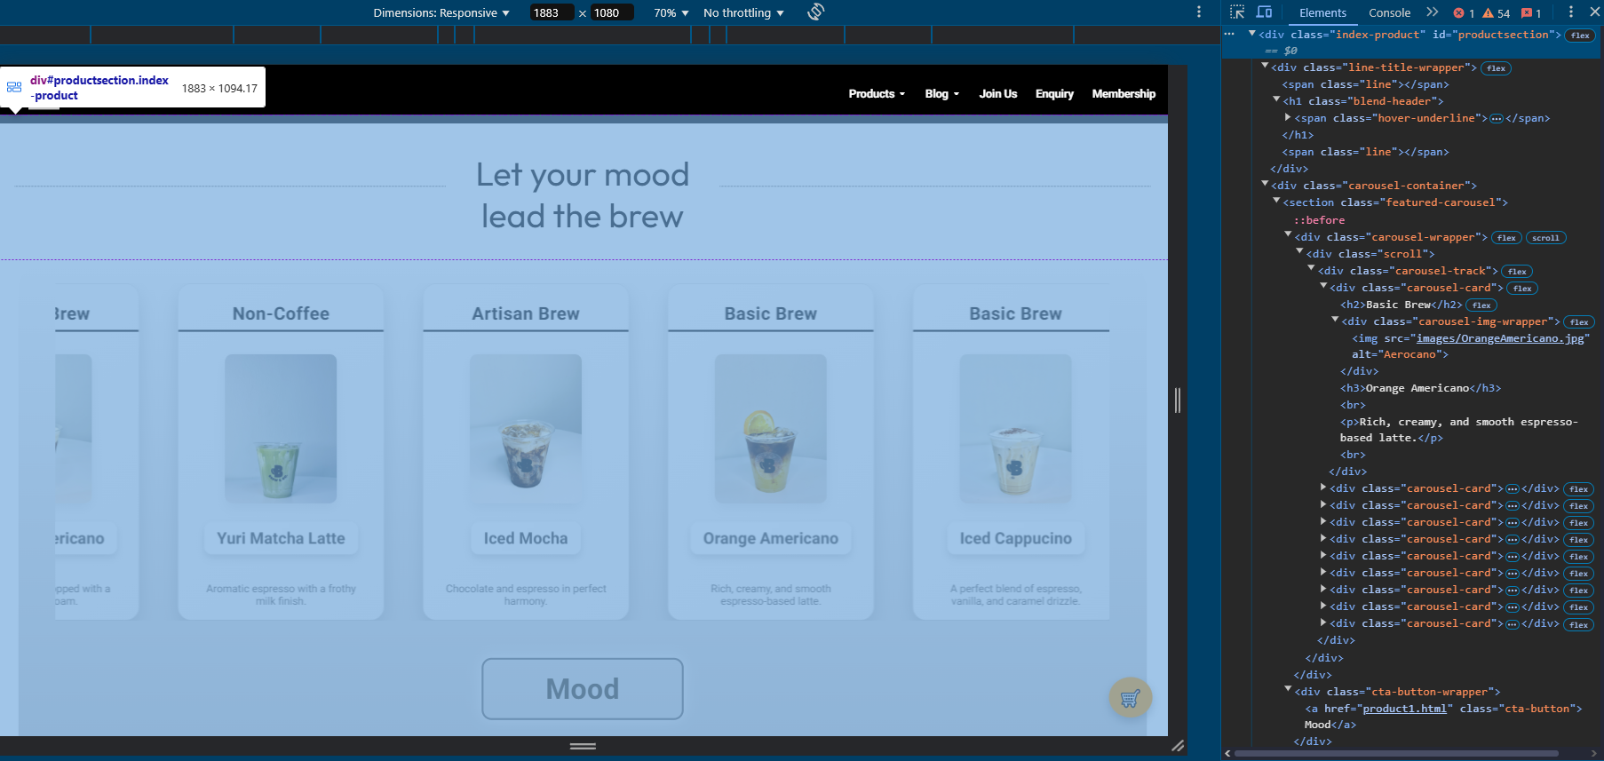

The homepage features a horizontally scrollable **Product Preview Carousel**, designed to immediately capture user attention and showcase a curated selection of Brew & Go’s beverages. This section sits directly beneath the animated hero banner and functions as a visually engaging highlight reel for products across various categories such as Basic Brew, Artisan Brew, and more. Each product is presented in a minimalist card layout using semantic HTML elements like <section>, <figure>, and <figcaption>, with structured <div> containers that enable fluid horizontal scrolling.

Cards within the carousel are enhanced with smooth hover animations — when a user hovers over a product card, the image subtly enlarges, lifts off the page, and casts a more pronounced shadow, creating an interactive, tactile experience that encourages exploration. A central call-to-action button labeled “Mood” is placed just below the carousel, directing users to the full menu on the product1.html page. The layout leverages CSS Flexbox and overflow styling to achieve seamless horizontal movement without requiring JavaScript. This component not only adds dynamic flair to the landing page but also strengthens product visibility by immediately placing top drinks in front of the visitor upon arrival.

### Membership Section

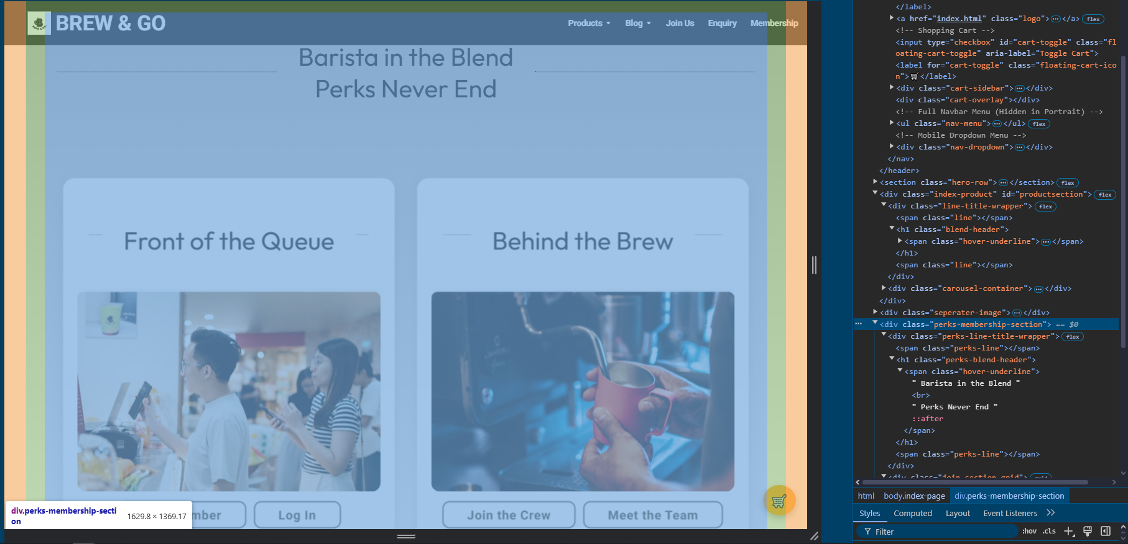

Further down the homepage lies the **Membership Section**, a two-part component designed to promote Brew & Go’s loyalty program and recruit new team members. The section is split into two interactive cards: *“Front of the Queue”* and *“Behind the Brew”*, which represent the customer membership program and crew hiring portal respectively. Each card uses a flip animation built entirely with HTML and CSS, providing a tactile visual cue as users hover over them. The front side displays promotional imagery, while the back reveals key information such as benefits, joining criteria, and call-to-action buttons.

These flip cards are implemented using <div> containers and CSS 3D transforms, ensuring responsive performance across devices without JavaScript. The animation is triggered on hover, making the interaction feel intuitive and lightweight.

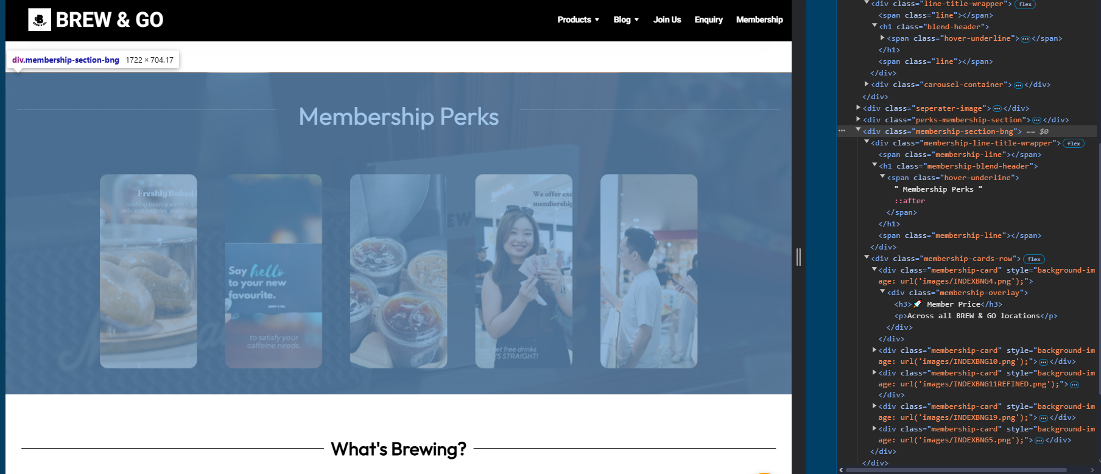

Below the main recruitment cards is the **Membership Perks** row, featuring five additional square cards that visually emphasize the benefits of joining Brew & Go — from lucky draws to free drinks and reward points. Each perk card uses subtle scaling and opacity transitions to draw attention on hover, and their layout is managed with Flexbox to maintain equal spacing and alignment regardless of screen size.

The entire section is enclosed within a <section> tag, keeping the structure semantic and maintainable. It serves both as a marketing highlight and functional gateway, funnelling users to the registration.html or joinus.html pages. Altogether, this section showcases Brew & Go’s commitment to community — both in terms of customer engagement and team culture.

### Latest News & Promotion

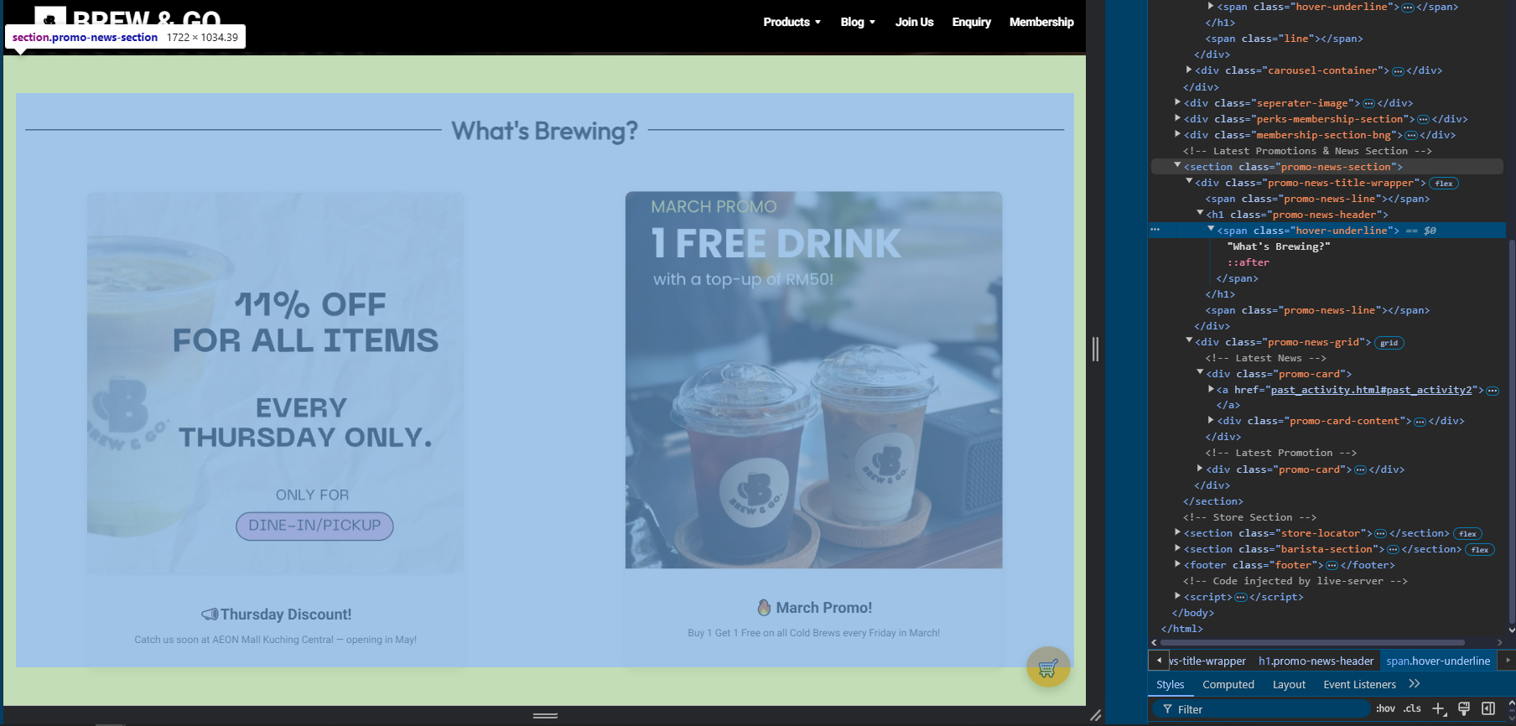

Positioned between the Membership Perks and Store Locator, the **Latest Promotions & News** section acts as a dynamic announcement board for time-sensitive updates and marketing campaigns. Titled *“What’s Brewing?”*, this section uses a clean two-column grid layout to feature the most recent promotions and upcoming store events.

Each promo item is structured within a .promo-card container that includes a clickable image and a text block with a headline and short description. The first promo highlights an upcoming **“Thursday Discount”** at AEON Mall Kuching Central with a link to the *Past Activities* section for more details. The second promotion features the **“March Promo”**, offering a “Buy 1 Get 1 Free” deal on Cold Brews every Friday — this card links directly to the *Current Activity* page.

The section uses <section>, <div>, and <img> tags arranged with CSS Grid, ensuring a responsive layout across different screen sizes. Hover effects, icon-based titles, and strong visuals ensure this area stands out while staying consistent with the rest of the site’s modern, clean aesthetic. Overall, this section supports the site’s marketing goals by actively drawing attention to current deals and reinforcing customer engagement.

### Location & Store Information

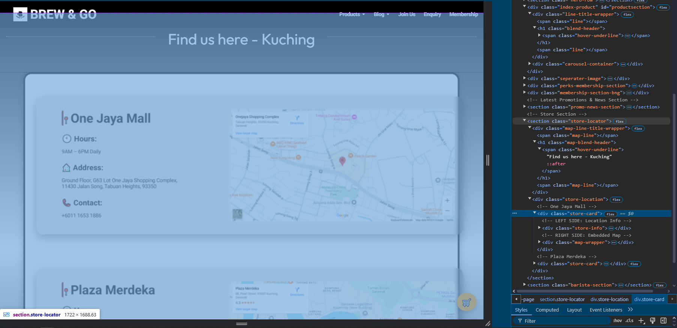

The **Location Section** highlights Brew & Go’s physical presence and encourages users to visit the nearest outlet. It features two cards representing Brew & Go branches located in **One Jaya Mall** and **Plaza Merdeka**, each complete with store details and an embedded Google Maps frame for interactive navigation.

Each store card is divided into two parts: the left panel shows structured details using <h2>, <h3>, and <p> tags for the store name, hours, address, and contact information, while the right panel embeds a Google Map using the <iframe> tag. This structure ensures clarity and accessibility, while also making it convenient for users to locate the stores via mobile or desktop. The maps allow users to zoom, scroll, and even switch to satellite mode directly from the site.

The layout is fully responsive, with Flexbox and adaptive sizing applied via CSS. Clear icons are used for visual cues (📍 for location, 🕙 for hours, 🏠 for address, 📞 for contact), enhancing the readability and user experience. This section serves both functional and promotional purposes, giving Brew & Go a grounded, real-world presence and emphasizing its active retail operations in Kuching.

### Video Section

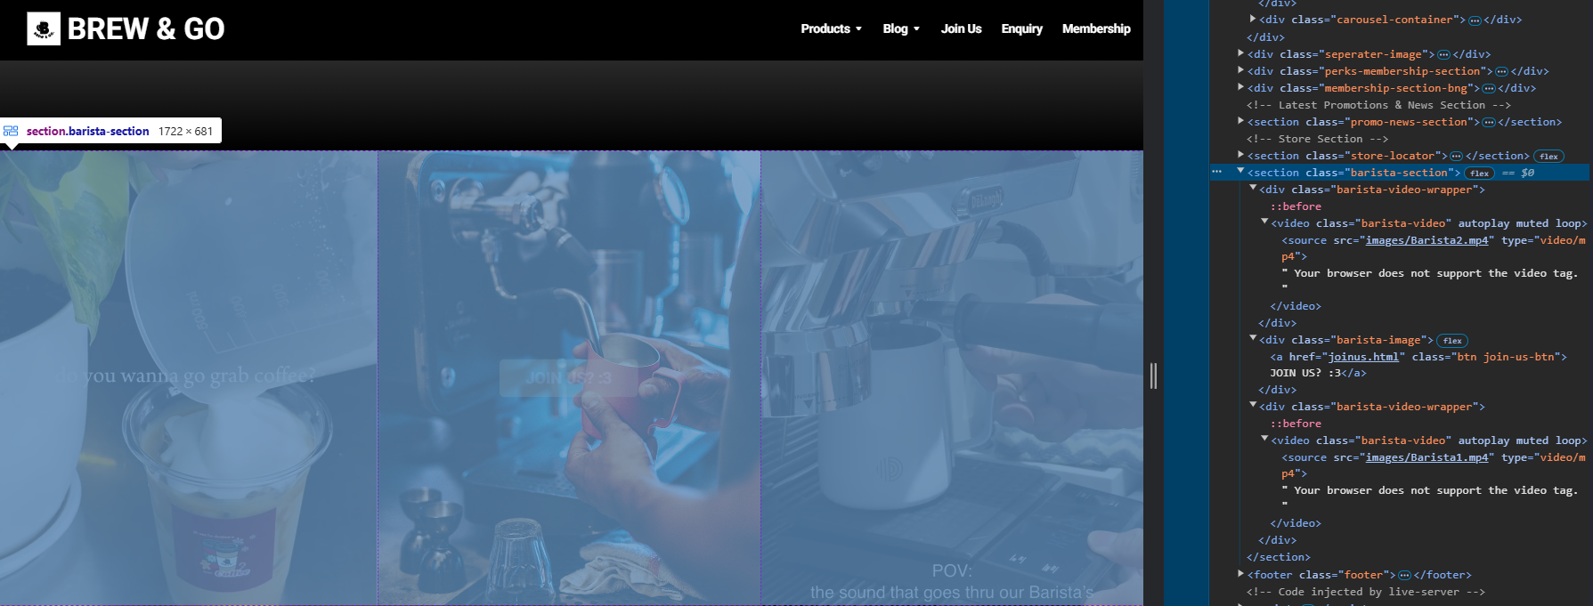

At the bottom of the homepage lies a visually engaging **video section**, designed to conclude the browsing experience with a memorable impression and a clear call-to-action. This section features two looping, muted barista videos placed on either side of a central button labeled **“Join Us? :3”**, encouraging visitors to explore Brew & Go’s career opportunities.

Each video is embedded using the <video> tag with the autoplay, muted, and loop attributes enabled, ensuring they run continuously and without audio interruptions. The layout is built using a combination of <section>, <div>, and responsive Flexbox styling to maintain equal spacing, scale, and positioning across devices. The videos themselves show behind-the-scenes footage of baristas in action — pouring drinks, steaming milk, and prepping orders — giving users a peek into the brand’s culture and day-to-day energy.

In between the two videos, the **“Join Us”** button links to the joinus.html page, which houses a detailed application form. This balance of motion, purpose, and invitation closes out the homepage in a way that is both modern and human, reinforcing Brew & Go’s commitment to growth, teamwork, and community engagement.

### Footer

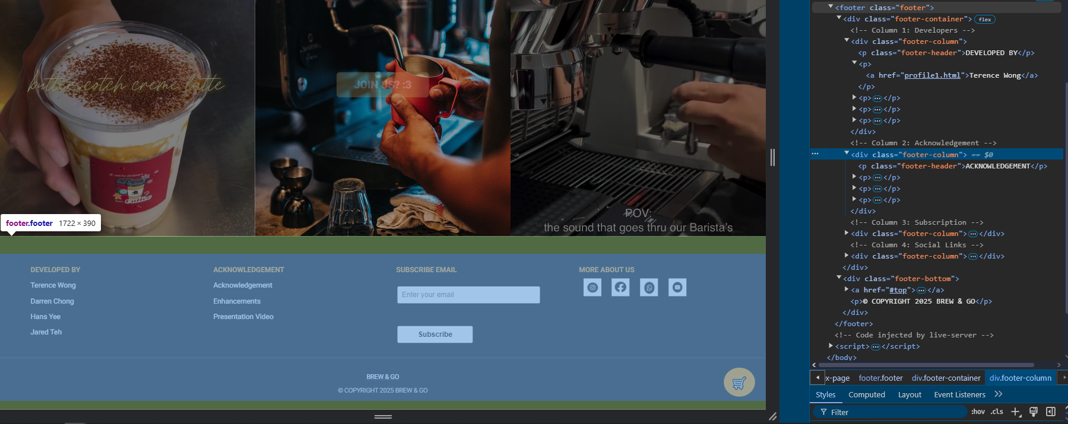

The **footer** of the *Brew & Go* homepage plays a critical role in reinforcing the website’s completeness, accessibility, and professionalism. It is divided into four well-structured columns, each serving a unique purpose, and styled to align with the overall aesthetic of the site.

* **Developer Credits**: The first column lists all group members involved in the project — Terence Wong, Darren Chong, Hans Yee, and Jared Teh — with each name hyperlinked to their respective profile pages.
* **Acknowledgements**: The second column provides quick links to the *Acknowledgement*, *Enhancements*, and *Presentation Video* pages, ensuring transparency regarding resources used.
* **Email Subscription**: The third column features a simple subscription form with an email input field and a “Subscribe” button. This promotes community engagement and reflects potential expansion features for the site in future iterations.
* **Social Media Links**: The final column showcases clickable icons linking to Brew & Go’s Instagram, Facebook, WhatsApp, and email, all implemented using <a> tags and styled <img> icons.

Beneath the columns is the **footer-bottom bar**, which contains a “Back to Top” link and a centered copyright statement.

This section is structured using <footer>, <div class="footer-column">, and other semantic elements for accessibility. Its responsive grid layout ensures readability on both desktop and mobile screens. Overall, the footer ties the site together by combining branding, navigation, and connectivity into a compact, visually balanced component.

## Products Page (Menu Page)

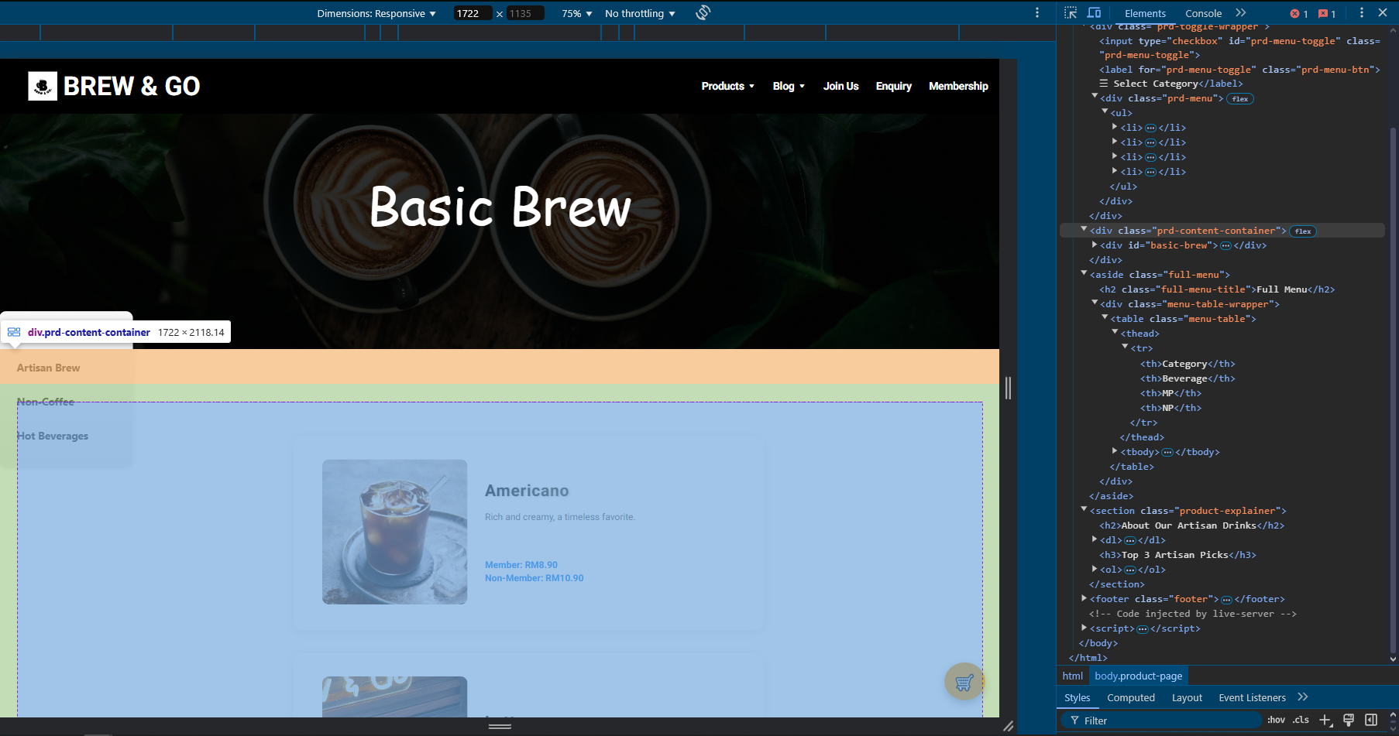

The *Product Pages* are split across four individual HTML files: product1.html (Basic Brew), product2.html (Artisan Brew), product3.html (Non-Coffee), and product4.html (Seasonal). Each page categorizes Brew & Go's drink offerings for better user navigation and focuses on clarity, consistency, and visual hierarchy.

Each product is presented using a <figure> element that wraps the product image, name, description, and pricing details. The accompanying <figcaption> ensures semantic accuracy while also improving accessibility and screen reader compatibility. To enhance visual clarity and maintain alignment across rows, products are displayed within a grid layout managed through CSS Flexbox.

Beneath each item:

* **Two pricing tiers** are shown — Member and Non-Member — helping reinforce the value of membership.
* Interactive **hover effects** are applied to product cards, subtly highlighting the entire row or enlarging the image to create a dynamic browsing experience.

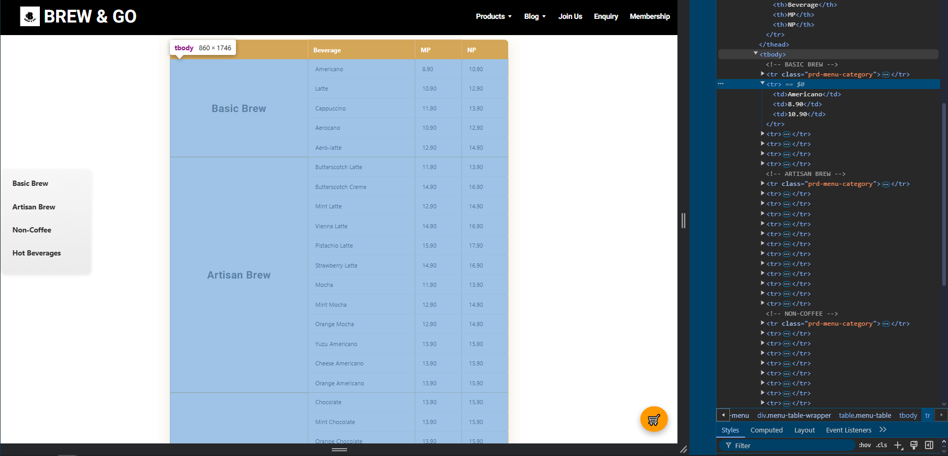

Every page also includes additional HTML5 semantic elements:

* <ol> lists are used for recommendations and drink highlights.
* <dl> (definition list) tags define unique drink ingredients or brewing methods.
* <aside> elements are occasionally used for fun facts, seasonal highlights, or ingredient notes — improving both structure and search engine readability.

To ensure visual consistency, all product pages share a unified structure, navigation menu, cart toggle, and footer. CSS class naming conventions (e.g., .prd-product-item, .prd-price, .prd-description) were maintained across all four pages, making styling predictable and maintainable.

These pages collectively offer a clean, responsive digital menu system — and provide the user with an organized, visually appealing experience when exploring Brew & Go’s beverage offerings.

### Products 1-4

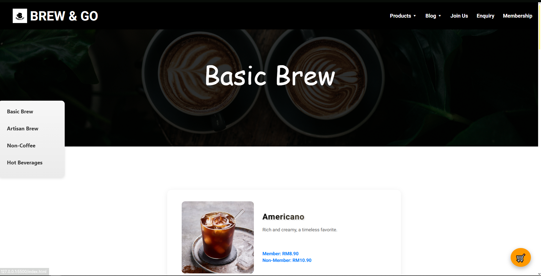

The Products Page section comprises four dedicated HTML files — product1.html, product2.html, product3.html, and product4.html — each representing a unique beverage category: Basic Brew, Artisan Brew, Non-Coffee, and Hot Beverage respectively. All four pages follow a unified layout structure, ensuring brand consistency and seamless navigation across the site. These product pages serve as categorized digital menus that help users explore the full range of Brew & Go's offerings in a clear, organized format.

Each product is structured using semantic HTML elements for accessibility and clarity. Every drink is enclosed within a <figure> element, accompanied by an image, product name, description, and tiered pricing shown in the <figcaption>. The dual pricing system highlights both Member and Non-Member prices, reinforcing the value of membership benefits. Lists of featured drinks and highlights are provided through <ol> tags, while <dl> elements are used to define ingredients or brewing methods. Additionally, <aside> sections are included on select pages to provide contextual side content such as seasonal notes or drink facts.

Despite the separation into different HTML files, the codebase across all four remains predictable and maintainable through standardized class naming conventions. Collectively, these pages establish a structured, user-friendly environment for exploring Brew & Go’s beverage range in detail.

## Blog (Activities & Event Page)

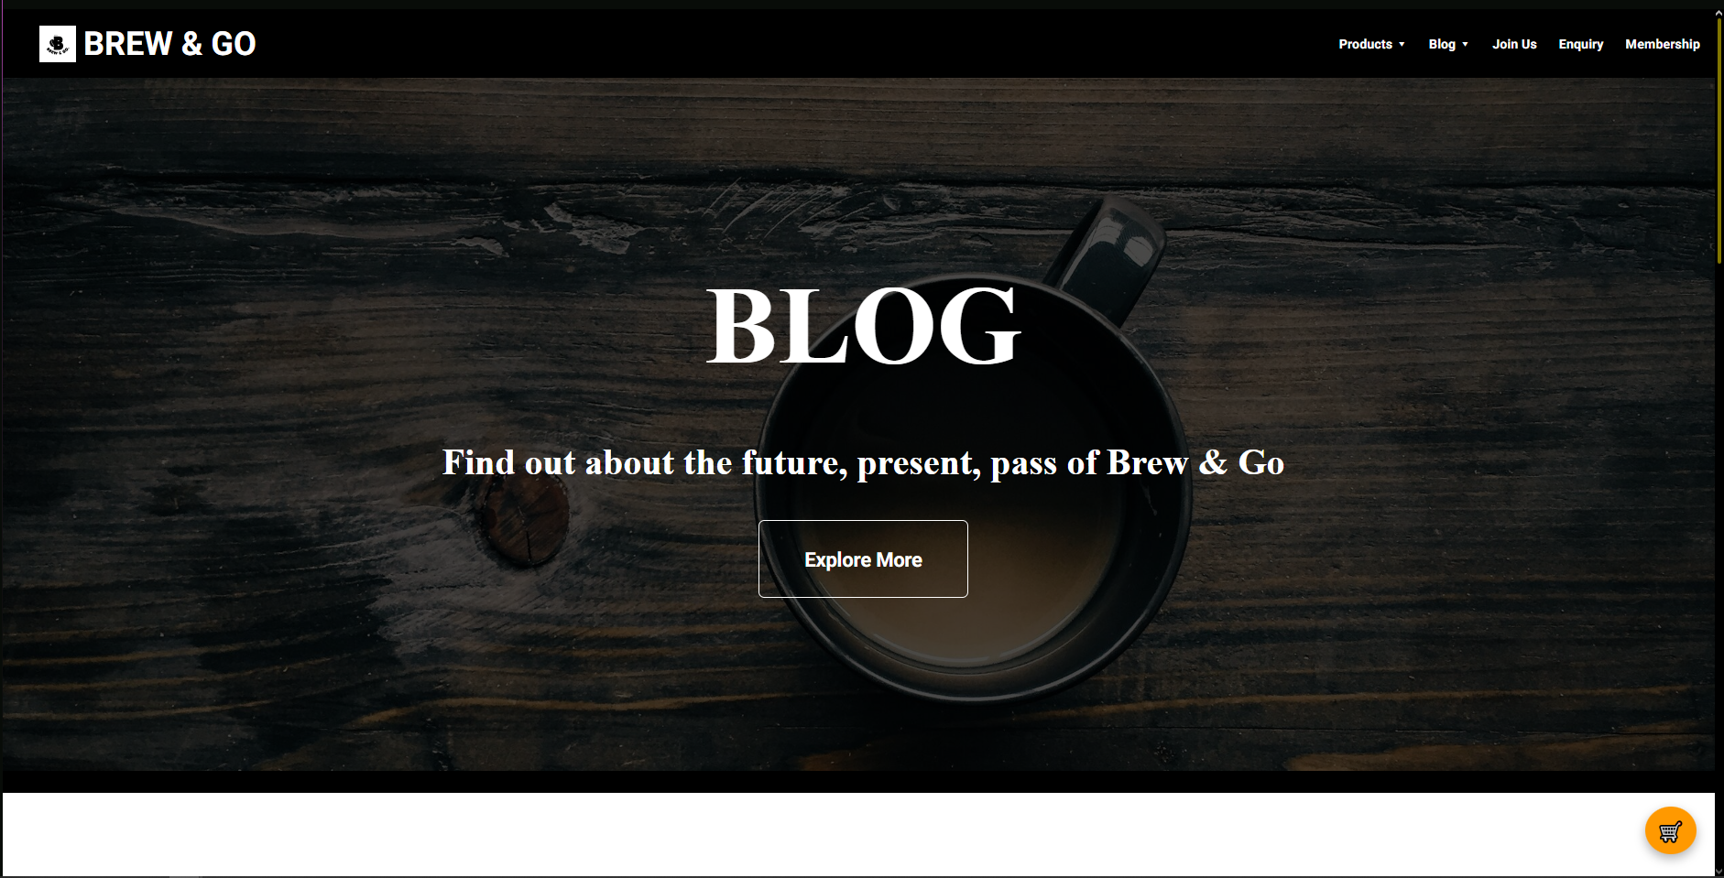

The blog.html page acts as a content hub that connects users to the three main activity subpages: coming_soon.html, current.html, and past_activities.html. Its purpose is to provide a summary and gateway for users interested in Brew & Go’s events, promotions, and ongoing campaigns. The layout of the blog page includes a **hero title section** introducing the blog and event categories, a **clickable slideshow** that cycles through highlights from recent and upcoming activities. Each slide is interactive, containing an image with a brief hover-over text description and a direct link to the corresponding activity page

This slideshow was implemented using HTML and CSS without JavaScript, with smooth image transitions and visual effects to engage the user. Text elements fade in or animate on hover to offer additional context, such as event names, dates, and teaser summaries. For example, images related to upcoming events link to coming_soon.html, while community recaps route users to past_activities.html.

From a semantic standpoint, the page uses <section>, <figure>, and <a> tags correctly, and media elements are optimized for responsive viewing. This page enhances user interaction by creating a dynamic gateway between promotional materials and actual content, encouraging visitors to explore Brew & Go’s brand beyond products.

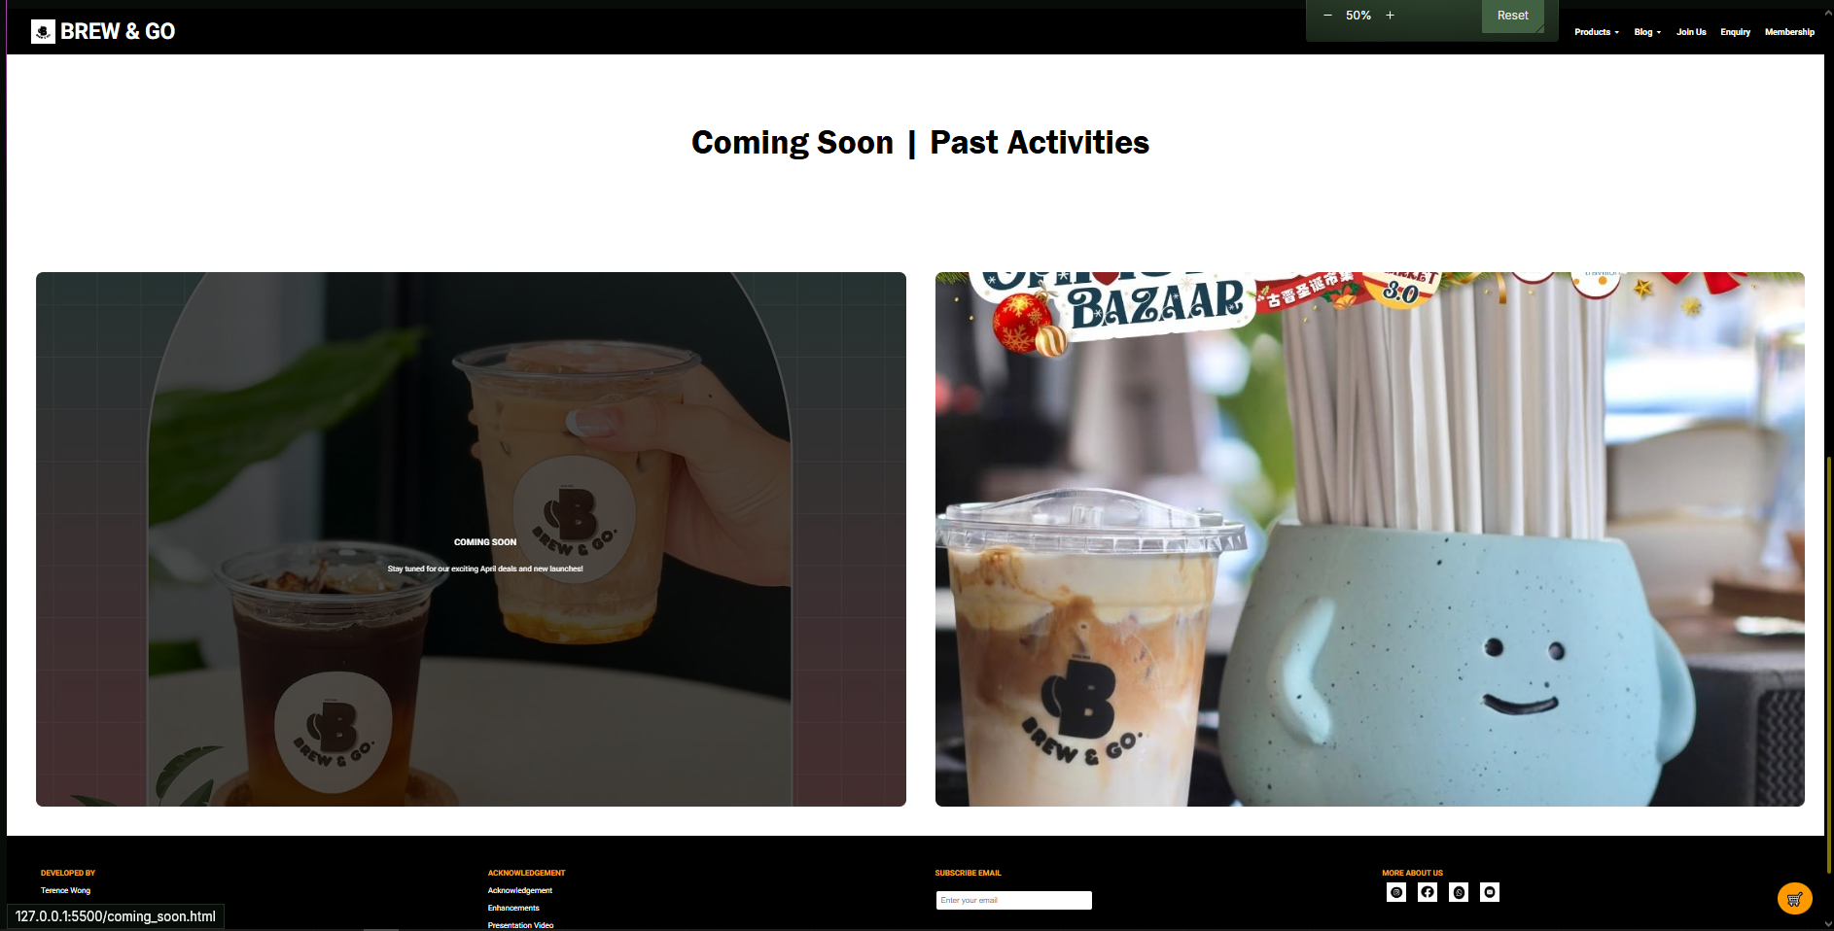

The layout of the blog page includes:

* A **hero title section** introducing the blog and event categories
* A **clickable slideshow** that cycles through highlights from recent and upcoming activities
* Each slide is interactive, containing an image with a brief hover-over text description and a direct link to the corresponding activity page

This slideshow was implemented using HTML and CSS without JavaScript, with smooth image transitions and visual effects to engage the user. Text elements fade in or animate on hover to offer additional context, such as event names, dates, and teaser summaries. For example, images related to upcoming events link to coming_soon.html, while community recaps route users to past_activities.html.

From a semantic standpoint, the page uses <section>, <figure>, and <a> tags correctly, and media elements are optimized for responsive viewing. This page enhances user interaction by creating a dynamic gateway between promotional materials and actual content, encouraging visitors to explore Brew & Go’s brand beyond products.

### Current Activities Page

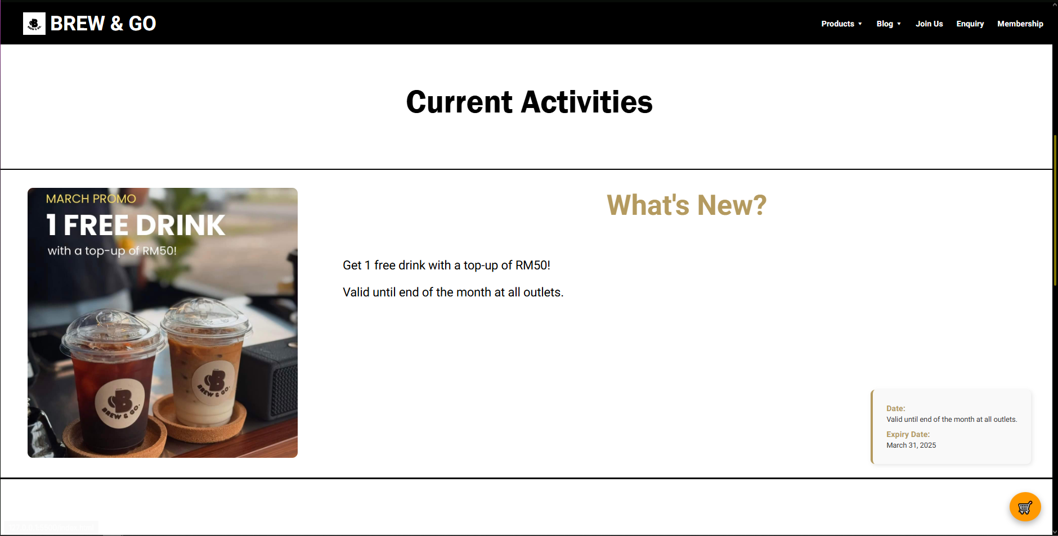

The current_activity.html page displays live or ongoing promotions. It includes an eye-catching event card featuring a high-quality product image, a description of the limited-time promotion, and an external link to Brew & Go’s Facebook page for real-time updates. This setup enhances interactivity and drives traffic toward social platforms while keeping customers informed about active deals

### Coming Soon Page

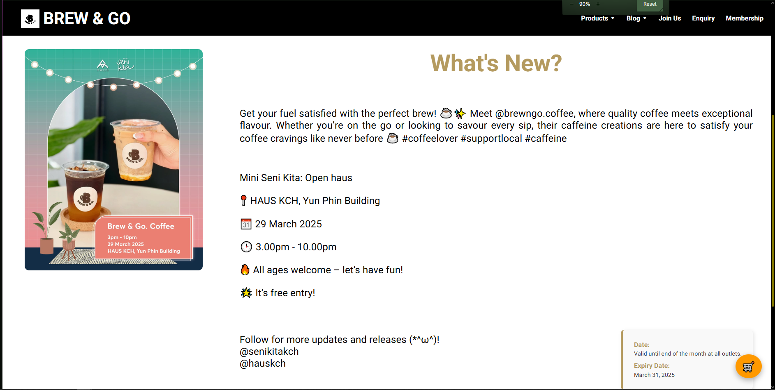

On the coming_soon.html page, upcoming events are highlighted in a single large section that combines an image, a short description, and a promotional video. The structure uses <figure>, <video>, and an <aside> panel to offer details like setup dates, hands-on activities, and location information. This modular and multimedia-driven format keeps visitors informed about what’s next while aligning with the overall aesthetic of the site.

### Past Activities Page

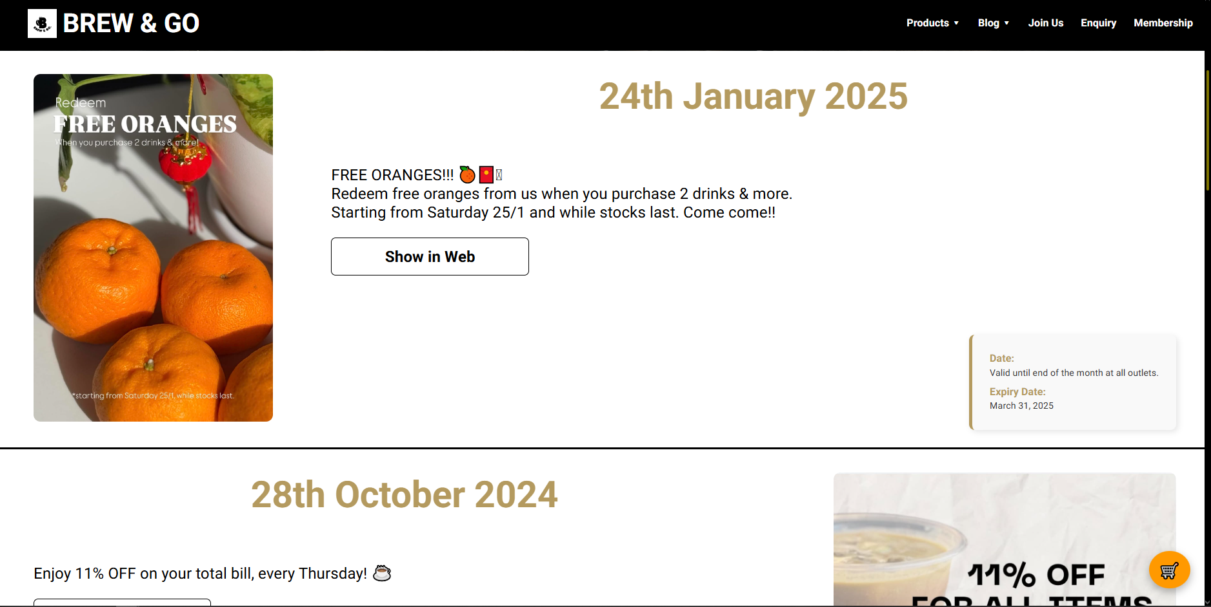

Lastly, past_activity.html compiles historical events and memorable moments, each presented in alternating left-right alignment for visual rhythm. Every activity is paired with its respective poster image, descriptive paragraph, and time-frame data presented within stylized cards. External links to Facebook posts and Instagram images allow users to revisit these events beyond the static webpage, offering archival transparency and celebrating Brew & Go's engagement history.

All blog-related pages feature consistent navigation, styling, and footer sections, maintaining design cohesion across the site. Together, these pages demonstrate how Brew & Go communicates brand personality and community involvement while integrating marketing goals within an engaging digital experience.

## Form Pages (Join Us, Enquiry, Registration, Login Pages)

The *Form Pages* are designed to collect essential user information for various functions, ranging from job applications to customer enquiries and membership registration. All four forms are structured with semantic HTML5 tags, clearly labeled fields, and built-in validation to ensure accuracy, accessibility, and responsiveness across devices.

### Join Us

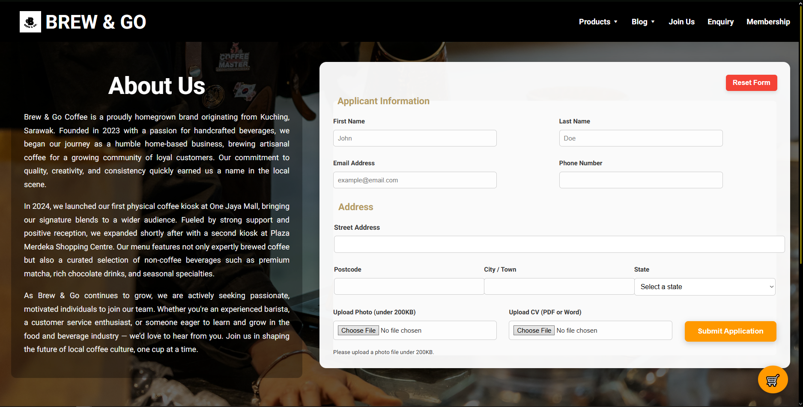

**Crew Application Form**

This page allows potential baristas or cashiers to apply to join Brew & Go’s crew. The form uses <fieldset> and <legend> for structure, along with labels for each field to support screen reader accessibility. Input types include text fields, radio buttons (for preferred shifts), checkboxes (for position choices), a file upload input, and a textarea for applicant messages. All fields are marked as required, and constraints like maxlength and proper patterns are applied.

### Enquiry

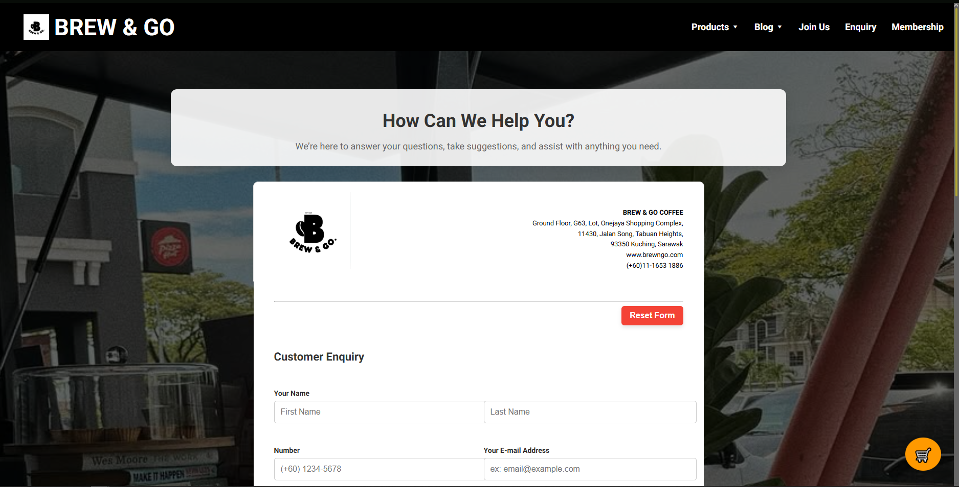

**Customer Enquiry Form**

This form is designed in a A4 size way that looks like a letter format, enables customers to submit feedback or questions. It includes a dropdown menu for Malaysian states, a pattern-validated 5-digit postcode input, a reason selector using <select>, and textarea for detailed enquiries. Input validation ensures consistent formatting and improves user experience. All field labels are clearly aligned, and tab order is logical.

### Registration

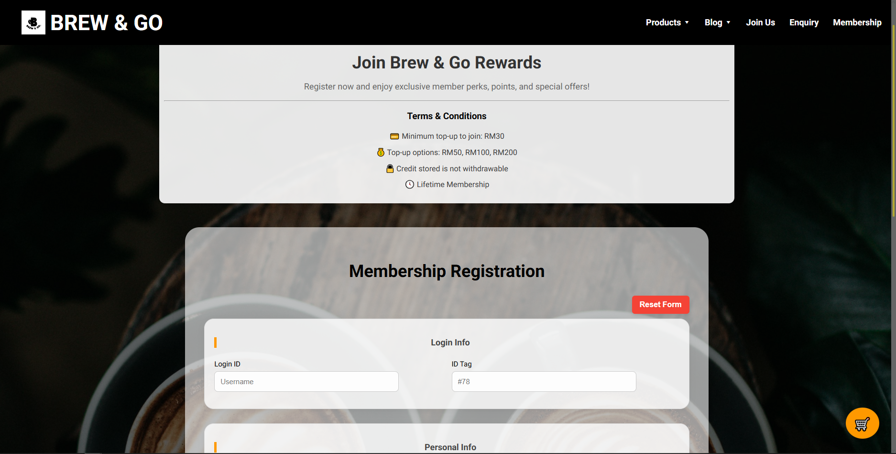

**Membership Sign-Up**

This form registers new members by collecting their name, email, phone number, login ID, and password. Each field uses appropriate input types like email, tel, and password, and is validated using required, pattern, and maxlength attributes. The form guides users through the process with placeholder text and a clean vertical layout, making it both functional and visually easy to navigate.

### Login

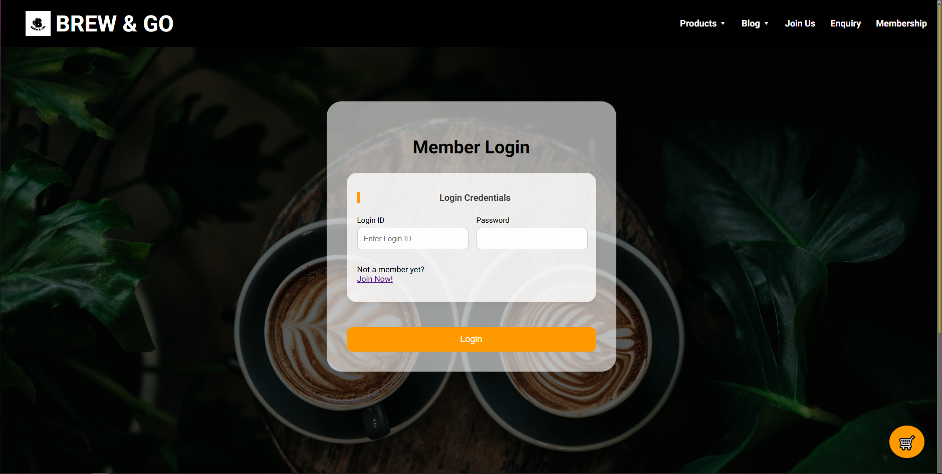

**Account Login**

The login page is a minimal form with two fields: Login ID and Password. Both fields are validated with maxlength and character limits, and placeholders are provided for guidance. Although the login action isn’t connected to a back-end system in this assignment, the structure anticipates future integration.

Each form page follows a consistent style and layout, using shared CSS classes and responsive media queries to ensure a clean experience on all screen sizes. Collectively, these pages showcase a strong understanding of form design best practices and future-ready thinking for user interaction.

## Profile Page

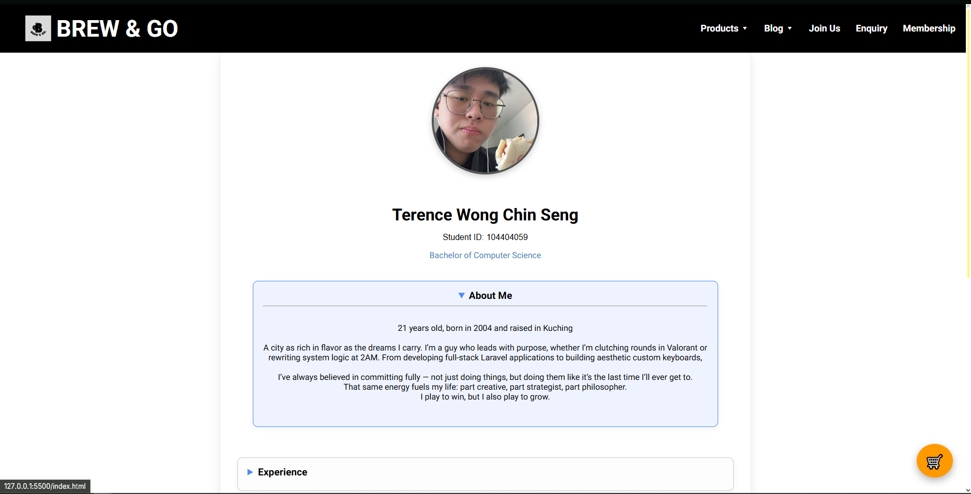

Each member of the development team has a dedicated **profile page**, created as part of the individual task requirement. These pages present both professional and personal information using a combination of structured HTML elements and custom CSS styling. The layout is consistent across all four profiles and adheres strictly to the formatting criteria outlined in the assignment brief.

|  |  |
| --- | --- |
| **Required Formatting Implementation** | |
| **Name** is displayed at the top of the page, centered, bolded, and styled with a font size of 200%. | **DONE** |
| **Student Number** is styled using the Arial font family, with a fallback to sans-serif, maintaining a clean and readable typeface. | **DONE** |
| **Course Name** is colored using an RGB value for visual distinction. | **DONE** |
| A **profile photo** is placed with float: left, styled with a **groove border**, 20px of padding, and file size optimized to stay under 100KB. | **DONE** |

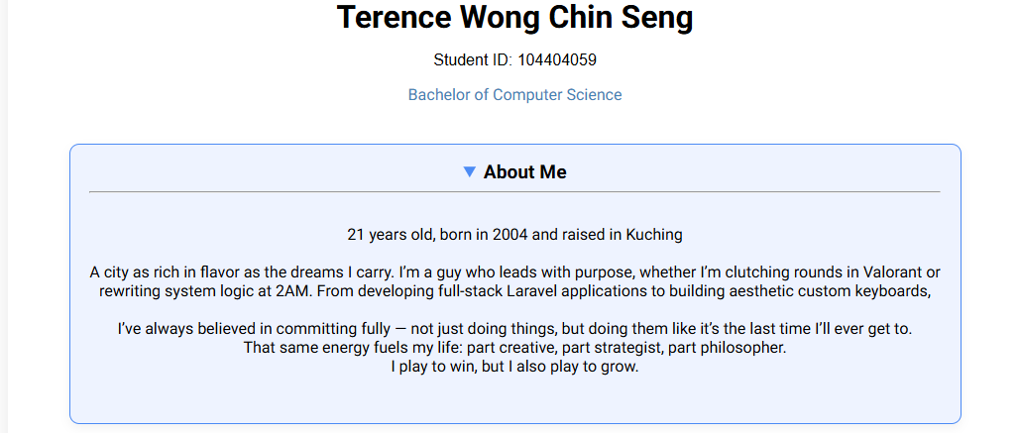

Each page includes a structured HTML <table> presenting:

* Demographic background
* Hometown details
* A major personal achievement
* A list of favorite books, music, games, or movies

The table is styled with:

* **Bold, centered headers**
* Background colors in **hexadecimal format** for each <td> to differentiate content
* Semantic use of <thead> and <tbody> for accessibility

## Enhancements

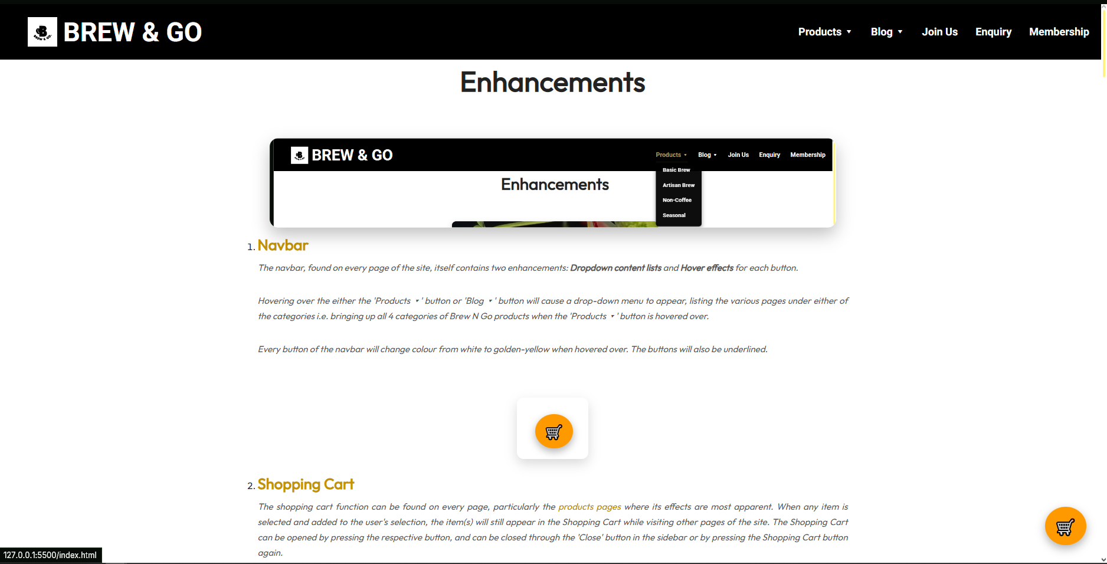

The enhancements.html page highlights twelve custom enhancements implemented throughout the Brew & Go website. This page serves as both a functional documentation hub and a creative showcase, presenting each enhancement with a brief description, preview image, and a direct link to the page where the enhancement is used. All enhancements were built using HTML and CSS exclusively, without the use of JavaScript, in accordance with the project’s technical constraints.

Among the most prominent enhancements is the responsive **dropdown navigation menu**, which includes hover underline animations and category-based submenus under "Products" and "Blog". The **floating shopping cart icon** is another core feature — present on every page — allowing users to toggle a sliding cart sidebar using only an input checkbox and label interaction. On mobile devices, the site dynamically transforms into a **mobile-optimized layout** featuring a hamburger menu, reflowed sections, and scroll-friendly components. These responsive behaviors are powered by media queries and Flexbox layout techniques.

The homepage features a horizontally scrolling **product carousel** that pauses on hover and uses card hover effects to animate images and text. Further down, the **membership section** incorporates CSS-based **flip cards** to display information on both customers and crew recruitment. Below that, an additional row of perk cards reveals content on hover through scaling and overlay effects. These animated cards offer both interactivity and visual depth.

The **store locator section** embeds two responsive **Google Maps** iframes, each paired with store details and contact information. The embedded maps support zoom and scroll, enhancing the physical connection to the brand. At the bottom of the homepage, a **video section** plays two looping barista clips flanking a central "Join Us" button — reinforcing the brand culture and human touch.

On the content side, the **blog slideshow** on blog.html automatically rotates through upcoming and past events, with clickable images and hover-revealed descriptions. The **product pages** implement a variety of semantic enhancements, including <figure>, <ol>, <dl>, and <aside> to structure detailed drink menus and promotional callouts. Even individual profile pages feature **expandable <details> sections**, custom icons, and floating image enhancements that meet both the functional and aesthetic goals of the project.

Each enhancement contributes to a smoother, more engaging user experience, and collectively they reflect a high level of effort, attention to detail, and front-end development fluency.

# Website Style

## Index Page Styling (Main Page)

### Navbar & Cart Icon + Sidebar

Style.css Line 73 – 337

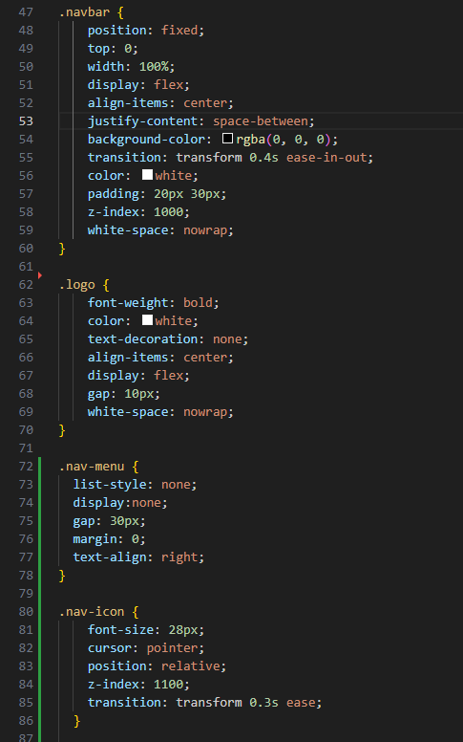

Overall Navbar Items:

* + .navbar
  + .logo
  + .nav-menu
  + .nav-icon

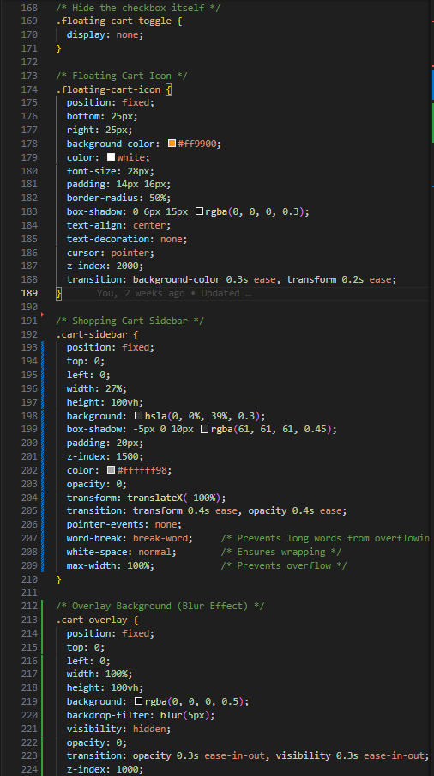

Overall Cart system:

* + .floating-cart-toggle,
  + .floating-cart-icon,
  + .cart-sidebar, .cart-overlay

This section handles the top black bar that stays fixed while scrolling, dropdowns, hamburger toggles, and the floating cart icon with slide-out panel.

### Hero Section

Style.css Line 341 - 461

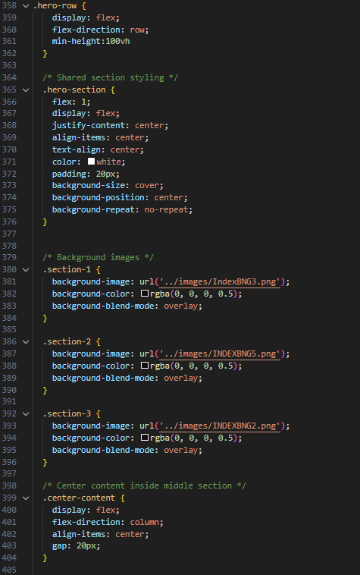

### Product Preview Carousel

Style.css line 476 - 758

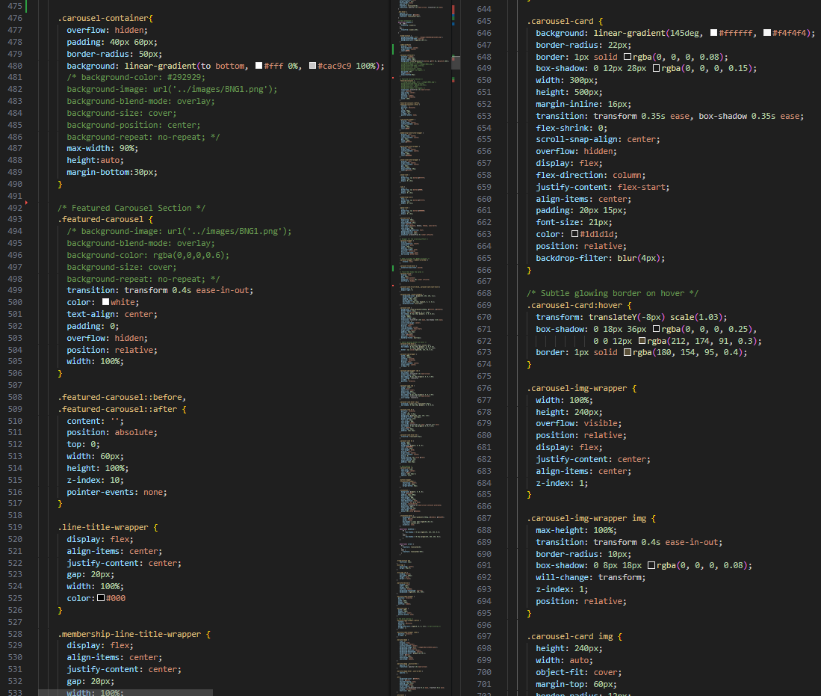

The .carousel-container section is the main visual frame for the scrolling product showcase. It sets a rounded, gradient-backed container with soft shadows to hold the carousel. Inside it, the .featured-carousel provides overall structure and visual alignment, ensuring content is centered and overflow is handled smoothly. The .carousel-wrapper enables horizontal scrolling and smooth behavior while hiding the scrollbar for a cleaner look. The .scroll class ensures a continuous flow of content, and the .carousel-track manages the horizontal layout of all cards using flexbox with even spacing.

Each individual item is wrapped in a .carousel-card, which presents a consistent card-like appearance with shadows, hover effects, and internal padding. Images are handled by .carousel-img-wrapper, which centers and scales visuals while preventing overflow. Together, these classes create an animated, modern carousel component that highlights products attractively and interactively.

The .carousel-track class is used to define the container that holds the scrolling carousel items in the homepage product slider. It's typically styled with a horizontal layout and smooth transition behavior to allow for animated sliding of .carousel-card elements.

* **.carousel-track {}**: This base style usually sets up:
  + display: flex; to arrange .carousel-card items in a row.
  + transition and transform properties to enable smooth scroll animations.
  + gap or margin between cards if needed.
* **.carousel-track:hover {}**: This pseudo-class is often used to apply hover effects, like pausing the animation or slightly scaling the items for interactivity.

### Membership Section

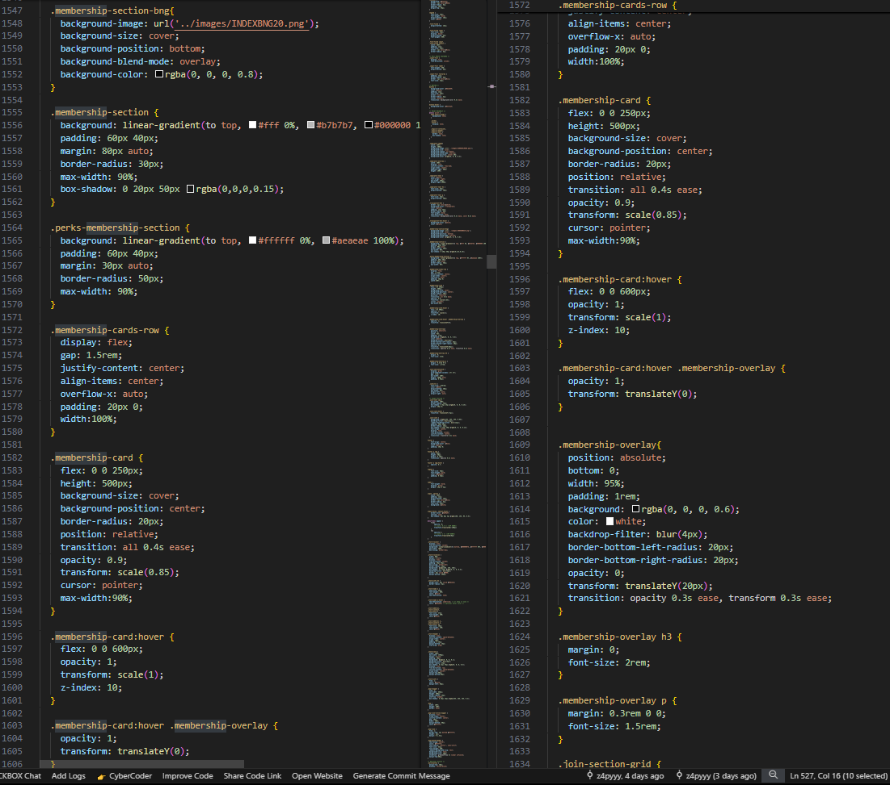

The **membership section** of the website is styled with several dedicated classes to create an informative and engaging layout. The main container .membership-section-bng organizes the entire section, while .membership-line-title-wrapper centers the heading with horizontal line elements using .membership-line to visually bracket the title. The title itself uses .membership-blend-header, which follows the site’s typography and hover underline style for consistency. Within the content area, .membership-cards-row arranges the cards horizontally in a row, displaying various membership perks. Each card uses .membership-card, which includes a background image set directly in the HTML and overlaid by .membership-overlay, a semi-transparent layer that holds descriptive text like headings and short benefit statements. This structure allows the section to visually stand out while clearly communicating the advantages of joining the Brew & Go membership program.

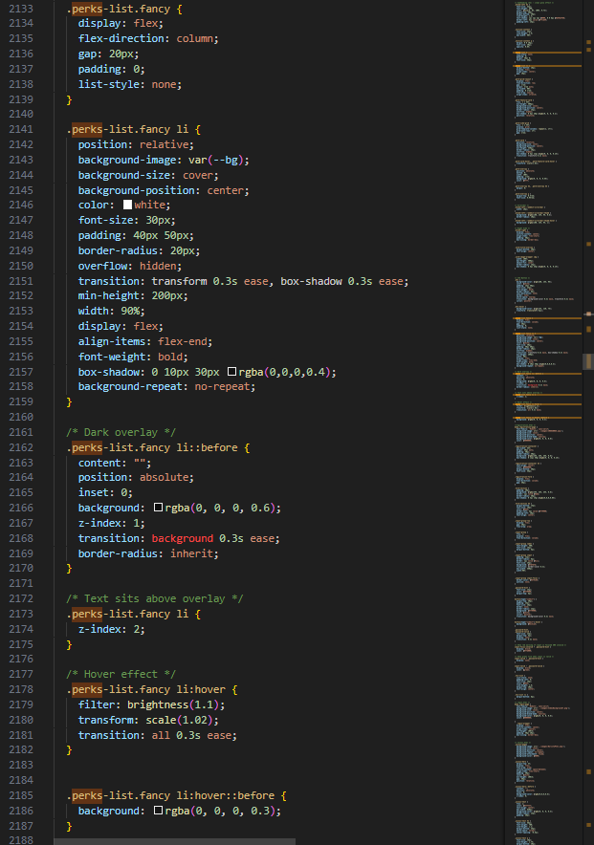

The .perks-list.fancy styles define a visually engaging and flexible column layout used to display membership perks. The list items are stacked vertically with spacing using flexbox and no bullet points. Each individual list item (.perks-list.fancy li) is styled as a bold, card-like block with a custom background image, padding, rounded corners, and a smooth transform transition for hover interaction. These blocks are designed with white text placed at the bottom using align-items: flex-end, and a semi-transparent shadow adds depth. To enhance readability, a dark overlay is applied using a ::before pseudo-element, which covers the background image with a translucent black layer while keeping the text above it (z-index: 2). On hover, each item subtly brightens and scales up slightly, with the overlay also adjusting its darkness to emphasize interactivity. This combination of layering, animation, and responsive layout results in a dynamic presentation of membership perks.

### Latest News and Promotion

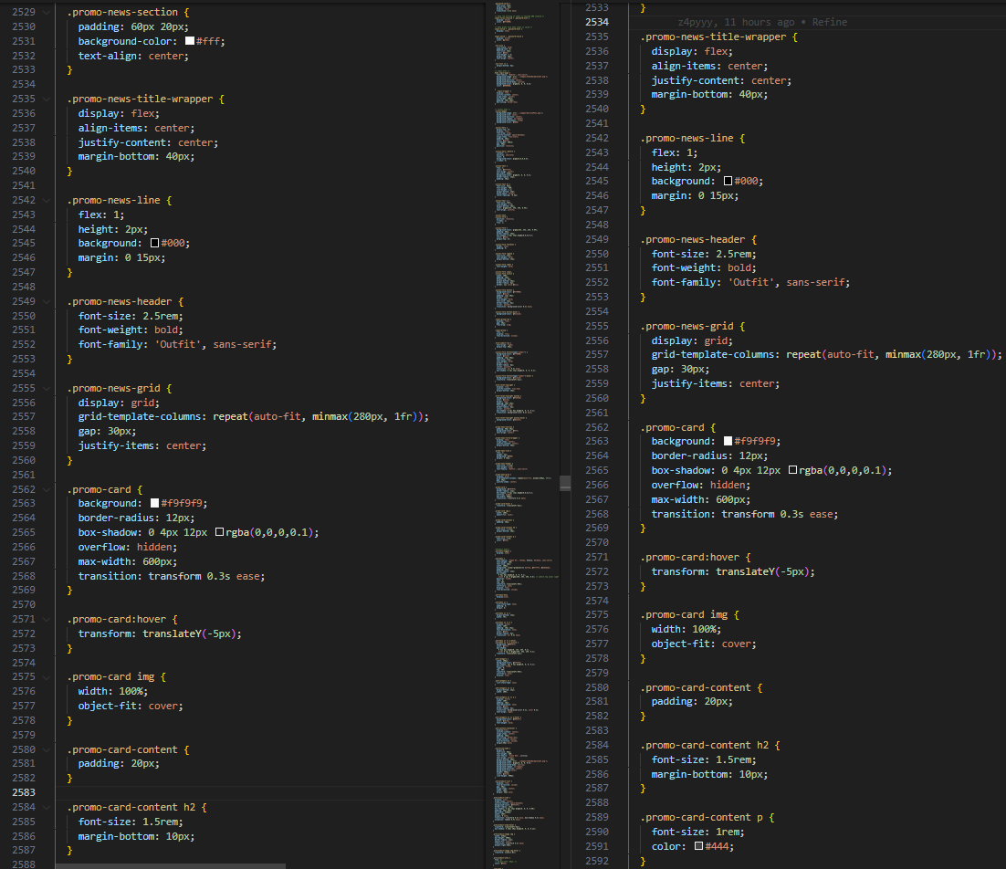

The .promo-news-section presents promotional highlights and updates in a neatly structured and visually appealing format. It begins with a padded white background and centered text. The .promo-news-title-wrapper centers the heading between two horizontal .promo-news-line dividers, creating a clean and modern look. The header itself (.promo-news-header) is bold, large, and styled using the 'Outfit' font for strong branding. Promotions are arranged within a responsive .promo-news-grid using a CSS grid layout that adapts to screen sizes with evenly spaced columns. Each .promo-card acts as a highlight box, featuring a soft pink background, rounded corners, subtle shadow, and a hover effect that shifts the card upward for interactivity. Inside each card, images are full-width with proper aspect coverage via object-fit: cover, while .promo-card-content wraps the title and description with ample padding. The heading and paragraph in the content block are clearly styled for readability, using well-sized fonts and margin spacing. This entire section blends functionality and design to effectively communicate ongoing deals and news.

### Location & Store Information

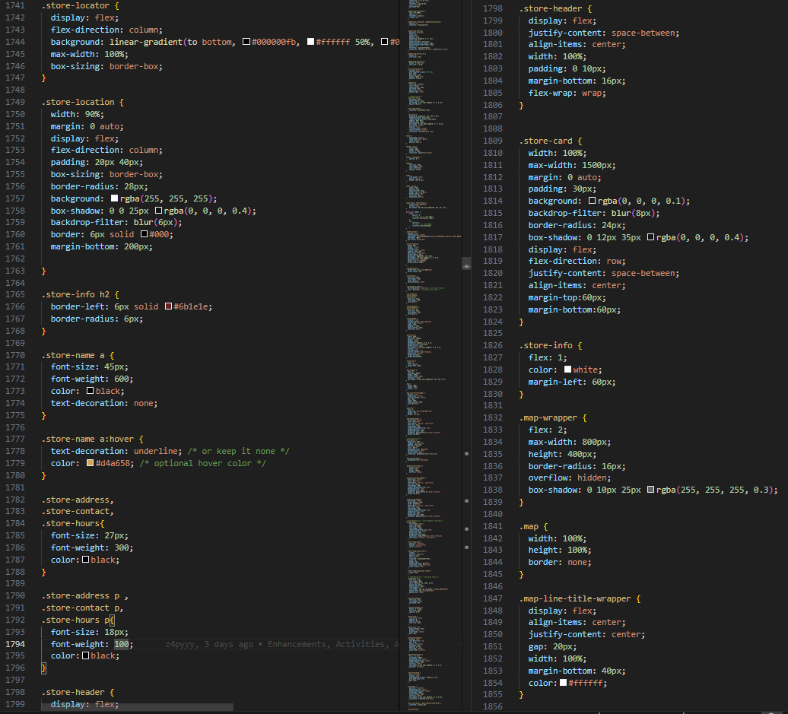

The Location & Store Information section delivers a modern layout for showcasing store details alongside embedded maps. The .store-locator acts as the primary wrapper with a vertical flex direction and a stylish linear gradient background. Nested inside, .store-location ensures a centered, column-aligned layout with spacious padding and rounded borders for a polished look. Each .store-card functions as a visual container for one store’s info, split into .store-info and .map-wrapper. Store information on the left includes headings (.store-name), subheadings like .store-address, .store-contact, and .store-hours, all styled for readability with distinct font sizes and weights. The hover effect on store names underlines them and changes their color to a muted orange for emphasis. The right section features .map-wrapper, allowing for embedded Google Maps with a defined height and max-width, rounded corners, and a subtle shadow. .store-header and .map-line-title-wrapper add structure and spacing, aligning content neatly while reinforcing visual consistency. Overall, the section combines modern aesthetics with functional store navigation.

### Video Section

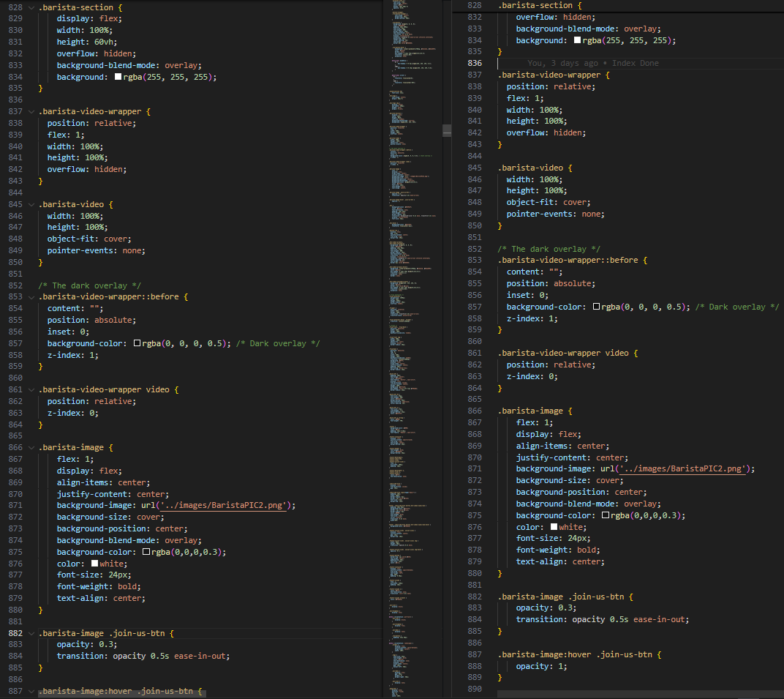

The Barista Section is a visually dynamic and interactive segment designed to promote crew recruitment through engaging video content. The parent container .barista-section utilizes flexbox to layout its child elements horizontally, with a fixed height and a soft white overlay using background-blend-mode for visual harmony. Each .barista-video-wrapper serves as a container for embedded looping videos, positioned relatively with full width and height while maintaining layering control using z-index. A subtle dark overlay is applied using the ::before pseudo-element with rgba(0, 0, 0, 0.5) to ensure content visibility over the video. Inside this section, the .barista-image block is placed centrally with a background image of a barista, styled with cover sizing and overlay blend for depth. The call-to-action button .join-us-btn is semi-transparent by default, becoming fully visible on hover, enhanced with a smooth transition. Typography is centered with bold white text, creating a balanced blend of informative and engaging design. This entire section invites users visually and interactively to explore job opportunities at Brew & Go.

### Footer

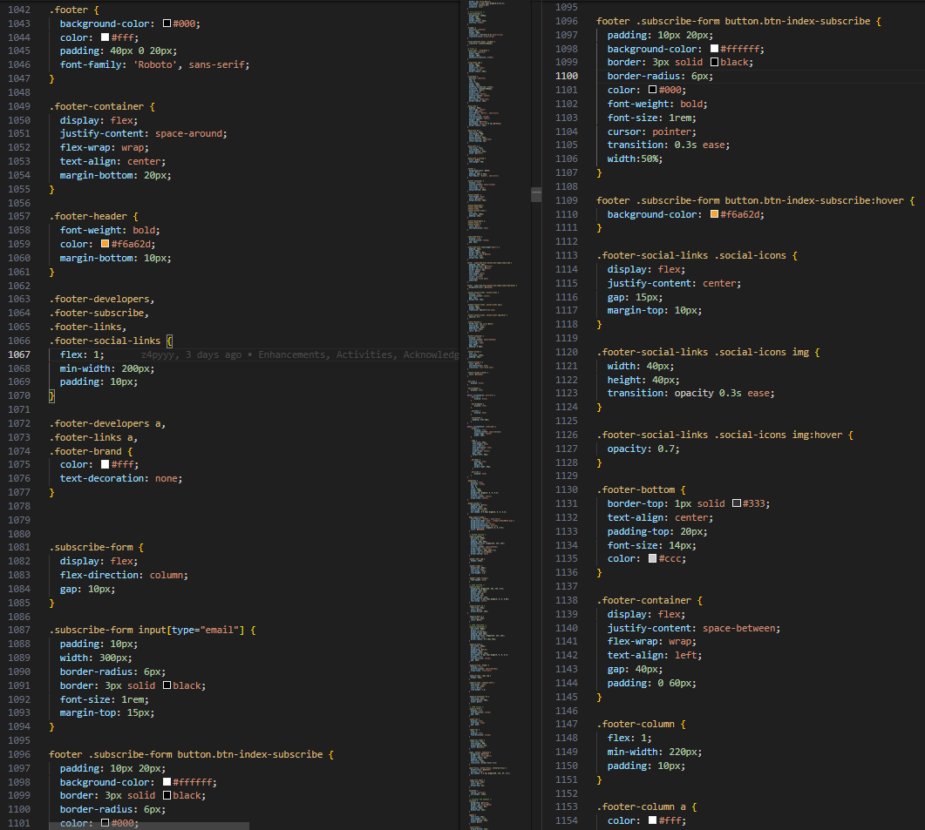

The Footer section is designed for informative clarity and structured layout, using .footer as the root class with a dark background and white text for contrast. The .footer-container uses a flex layout with space-around and wrap behavior to distribute columns evenly across different screen sizes. Each section, such as .footer-developers, .footer-subscribe, .footer-links, and .footer-social-links, is styled to occupy flexible space with padding and minimum width for readability. Link elements within .footer-developers and .footer-links are styled without underlines and colored white, preserving a clean visual hierarchy. The .subscribe-form aligns email inputs and buttons in a vertical column with consistent spacing. The email input field features padding, a subtle border, and round corners, while the .btn-index-subscribe button is styled with contrasting black text on a white background, changing color on hover to match the site’s accent. Social media icons are centered, sized uniformly at 40x40px, and include a fade effect on hover for interactive feedback. The .footer-bottom includes a top border, centered copyright text, and subtle gray tones. Overall, the footer provides a polished, responsive, and accessible closure to the website.

## Products

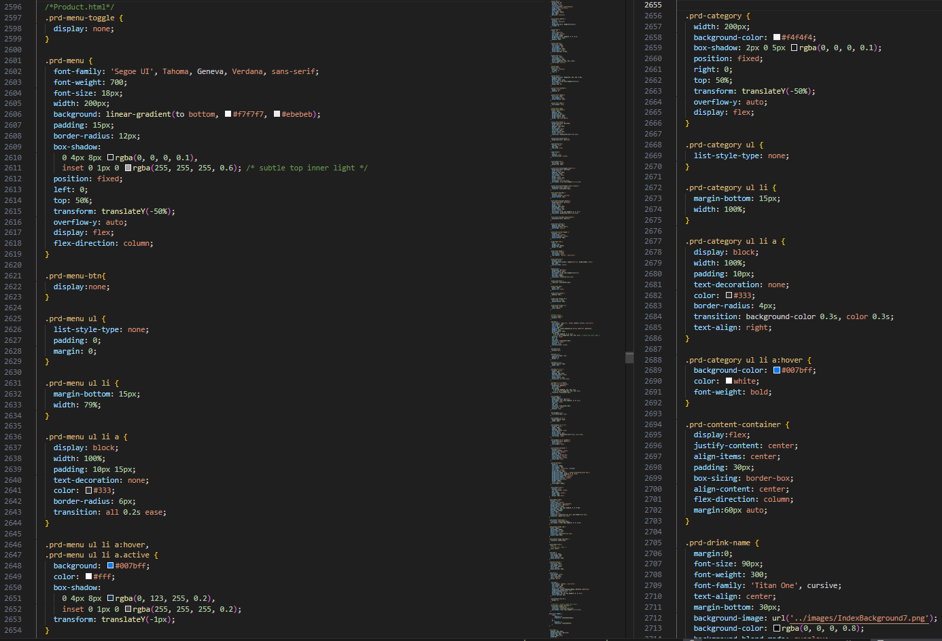

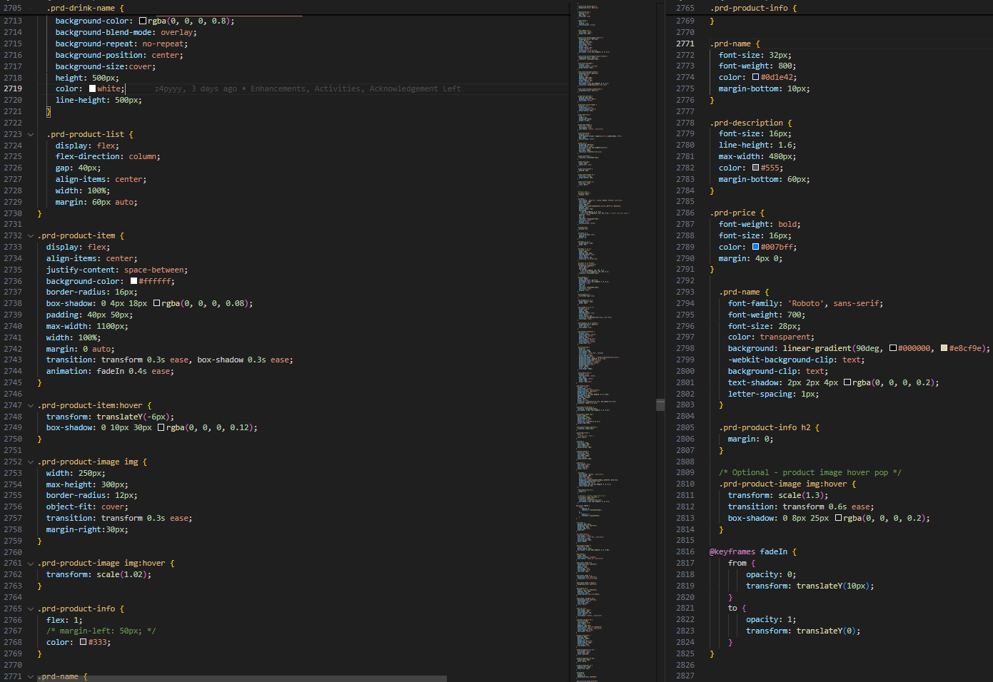

### Drink Name Section (.prd-drink-name)

The product page begins with a prominent header that clearly displays the current drink category (e.g., "Basic Brew", "Artisan Brew"). Styled using the .prd-drink-name class, it features bold typography and a full-width darkened background image that enhances contrast and readability. The text is center-aligned both horizontally and vertically, creating an engaging visual introduction to each category.

### Category Toggle Section (.prd-toggle-wrapper, .prd-menu-toggle, .prd-menu-btn, .prd-menu)

This section implements a responsive toggle menu that allows users to quickly switch between different drink categories. A checkbox input (.prd-menu-toggle) controls the visibility of the dropdown menu. The toggle button (.prd-menu-btn) is designed as a wide, blue-highlighted clickable label with clear, bold white text. When activated, the .prd-menu becomes visible with a smooth transition, presenting drink category links as list items styled for visual clarity and easy navigation. The entire section improves user experience on mobile by using a JavaScript-free toggling mechanism with just CSS selectors.

### Product Grid Section (.prd-content-container, .prd-product-list, .prd-product-item)

The core of the page lies in the product display grid, where beverages under the selected category are showcased. The .prd-content-container centers the entire layout and maintains consistent padding. Inside it, .prd-product-list uses a column-based flex layout with a comfortable gap between each item. Every individual drink is presented as a .prd-product-item, a styled figure with a shadowed card-like appearance. Each item displays an image on the left and drink details on the right, creating a clean and scannable layout ideal for both desktop and mobile.

### Drink Info Block (.prd-name, .prd-description, .prd-price)

Each product card includes detailed information broken down into multiple elements. The .prd-name class renders the drink title in a bold, modern typeface, often enhanced with a gradient or subtle color contrast for emphasis. Descriptions under .prd-description provide brief but enticing summaries in a lighter font for easy reading. Prices are displayed using .prd-price, styled in blue tones to draw attention to both member and non-member pricing. This clear distinction makes it easy for users to understand the value offered through membership.

### Full Table Menu (.full-menu, .menu-table, .menu-table-wrapper, .prd-menu-category)

Below the product grid, a comprehensive .full-menu section provides a full drink listing in tabular form. The .menu-table-wrapper centers the content within a visually padded box, while the .menu-table presents data in structured rows and columns. Each product category is grouped using the .prd-menu-category class to separate drinks by type. The table alternates row colors for readability and uses hover effects for interactivity. It includes headings for category, drink name, member price (MP), and non-member price (NP), ensuring transparent pricing and full menu visibility.

### Product Explainer (.product-explainer)

Concluding the page is a descriptive section meant to provide additional context and product storytelling. The .product-explainer class defines a neatly styled section with rounded borders and soft background, containing definition lists (<dl>) and ordered lists (<ol>). Each <dt> highlights the drink name while <dd> provides an informative description about its flavor profile or ingredients. This is followed by a Top 3 Picks list using an <ol>, guiding customers toward the most popular or recommended items. It adds a personal touch and enhances the shopping experience through curated suggestions.

## Blog (Activities & Event Pages)

### Blog

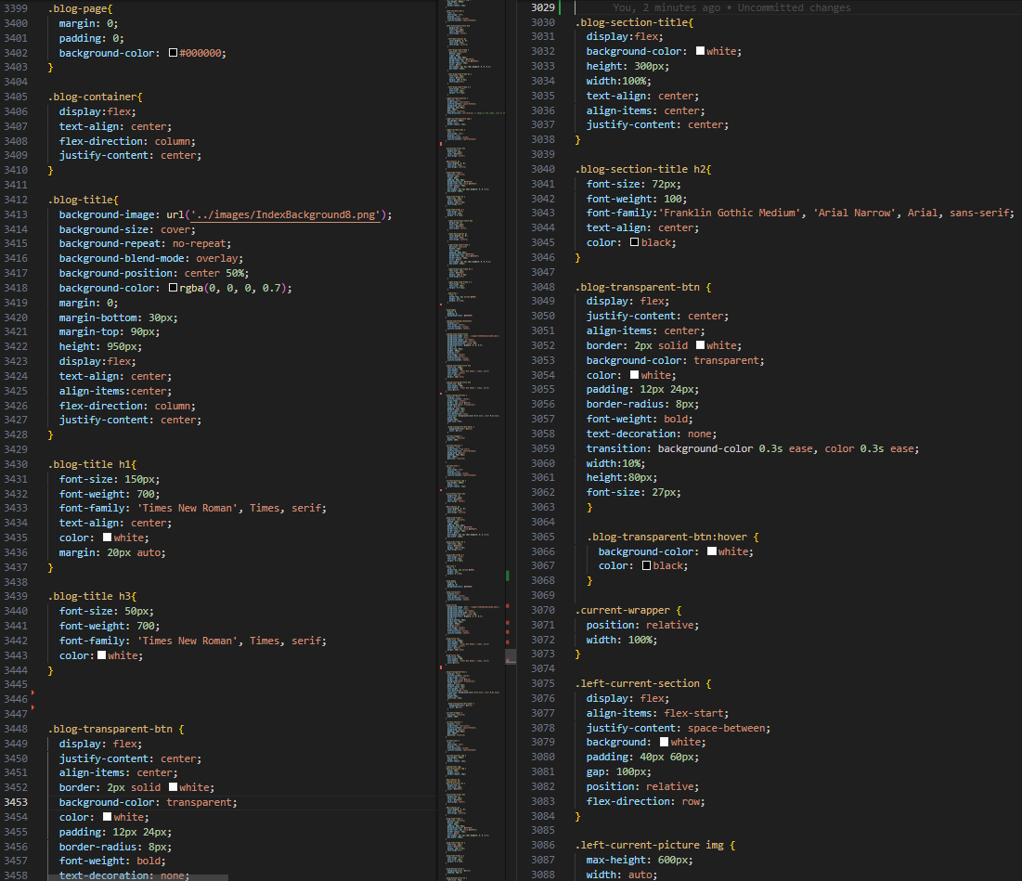

The blog-container wraps the main blog content and introduces the page with a visually strong title section (blog-title). It includes the <h1> for “BLOG”, a subheading <h3> for the slogan, and a button styled with blog-transparent-btn to lead users to the activities section below.

**▸ Current Activities Section**

Identified by the ID current-activities, this part uses a blog-section-title to highlight the section. A line-title-wrapper provides a horizontal line for visual separation. The top-row wraps current-wrapper, which contains current-section—this displays a current promotional image (current-picture), related text (current-info), and a date range (blog-time-frame). Together, these inform users of the latest event details clearly and responsively.

**▸ Coming Soon & Past Activities Overview**

This lower segment is grouped into a bottom-row, which includes a coming-soon-box with hoverable image and overlay caption (coming-caption) leading to the Coming Soon page. Adjacent to it is past-activities, which contains a past-slideshow that cycles through multiple past-slide divs with event posters and date captions.

### Coming Soon

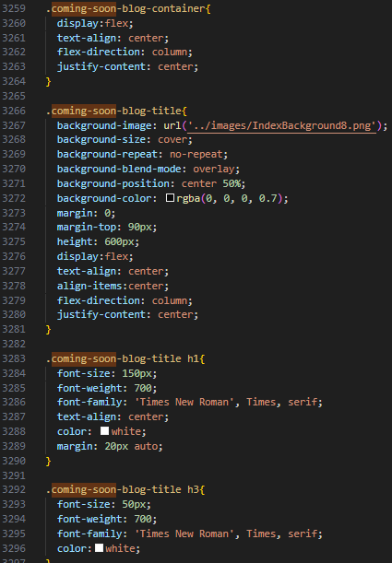

The content begins with coming-soon-blog-container, setting up a clear identity for the page. Within it, coming-soon-blog-title provides a large welcoming heading (Upcoming Events) and a smaller subtitle.

▸ Highlighted Event Block

The top-row structure is reused here for layout. Inside, current-wrapper and current-section hold an event image (current-picture) linked to the Instagram post, a text block (current-info) filled with event details, and a blog-time-frame that displays a date range. These components mirror the layout of the blog page for consistency, while the content itself is centered on upcoming events like Mini Seni Kita.

### Current Activity

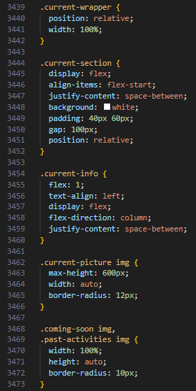

Interestingly, this page uses the exact same structure and class names as coming_soon.html. The same coming-soon-blog-container, coming-soon-blog-title, top-row, current-wrapper, and current-section layout patterns are used. The content is different, emphasizing present-time events or ongoing promotions.

▸ Informative Text

The textual content in current-info uses paragraphs to describe the activity, including its context, partners, and timing. The reuse of components allows easy maintenance and a uniform look across events.

### Past Activity

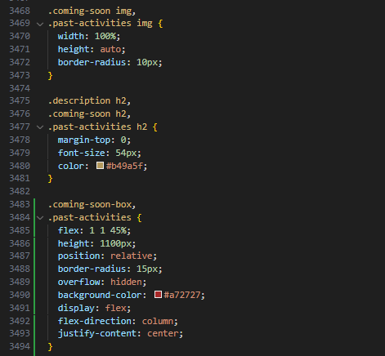

Like current_activity.html, this file uses coming-soon-blog-container, and all its nested components like top-row, current-wrapper, current-section, and blog-time-frame are reused. However, the actual imagery and text are focused on historical events or completed campaigns.

▸ Layout Strategy

The consistent use of current-section even for past content is a strategic choice that simplifies design. The only changing elements are the media (images) and paragraph content, while the layout remains completely uniform.

## Join Us & Enquiry

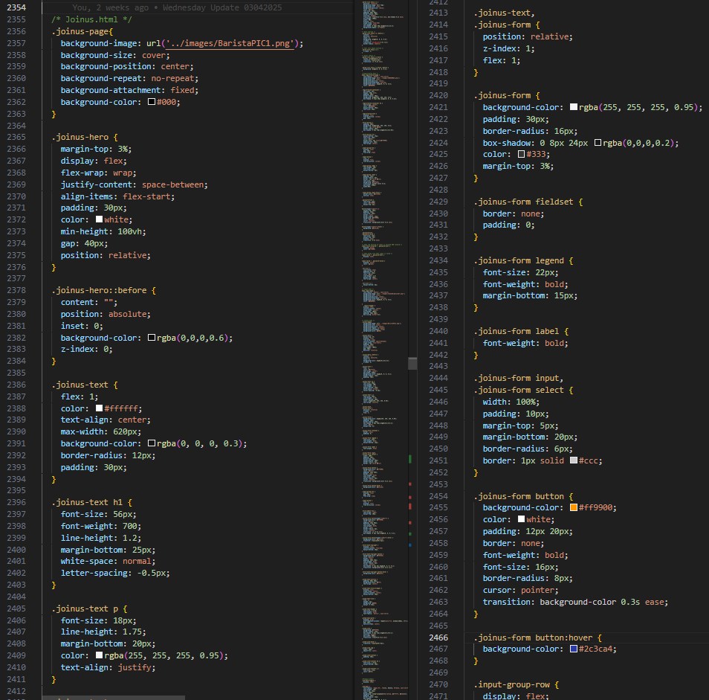

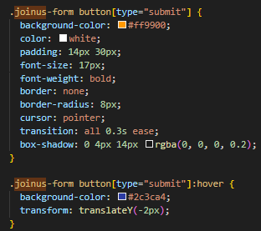

**▸ Page Structure & Layout**

Both the joinus.html and enquiry.html pages follow a consistent and professional layout that aligns with the overall theme of the Brew & Go website. Each begins with a full <header> section containing the navigation bar, logo, and shopping cart functionality. This is followed by a hero banner with a centered page title and introduction. The main content of both pages is vertically stacked, with the form section placed inside a styled container (joinus-form or enquiry-form) that visually separates it from the background using padding, rounded borders, and controlled width to maintain focus and readability.

**▸ Form Containers & Input Design**

Each form is wrapped in a specific class—joinus-form or enquiry-form—which governs styling like form width, background color, margin spacing, and padding. The input fields inside both forms are uniformly styled using CSS, ensuring consistent spacing, font size, and input height. Labels are aligned with their respective fields for accessibility and clarity. Buttons for **Submit** and **Reset** are positioned vertically, one on top of the other, for both pages as per user experience design consistency.

**▸ Join Us Specific Features**

The joinus.html form includes a radio button group for selecting the preferred working shift and a file upload input field for resume submissions. These inputs are laid out cleanly within fieldset and legend elements to semantically group related fields. All entries are validated with HTML5 features such as required attributes and appropriate input types (e.g., email, text, file). Additionally, a brief paragraph at the top introduces the form’s purpose—recruiting new team members to the Brew & Go family.

**▸ Enquiry Specific Features**

The enquiry.html page is designed for customer communication and feedback. It uses similar form elements but is structured to capture messages, contact info, and topics of concern. A textarea is included for open-ended feedback or detailed questions, styled to visually match other inputs. The design retains the same look-and-feel as joinus.html, ensuring consistency in layout, font choices, and mobile responsiveness.

## Membership

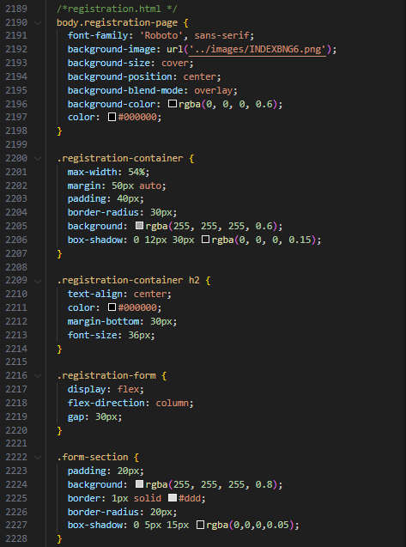

**▸ Page Structure & Layout**

The membership.html page adopts the same structural template as joinus.html and enquiry.html, ensuring design consistency across all form-based pages. The layout is vertically oriented with a full navigation <header> at the top, followed by a prominently styled banner area and main content container that divides the page into **membership information** (top half) and **registration form** (bottom half). This split layout allows visitors to first understand the benefits and requirements before filling out the form.

**▸ Membership Information Section**

The top half of the page is wrapped in a membership-info-section container (or equivalent), showcasing key details about the membership program. This includes headings such as “Member Perks” or “Why Join?”, short paragraphs that describe the lifetime perks, and sometimes an image or QR code on the side. This section also features horizontal lines or borders (like .membership-line-title-wrapper) to emphasize headers, giving the page a polished visual hierarchy. The typography and spacing mirror the styling of similar sections in the homepage and membership promo banners, reinforcing visual consistency.

**▸ Membership Registration Form**

The bottom half consists of the actual registration form, encapsulated within the registration-form class. This form mirrors the styling logic of joinus-form and enquiry-form but uses its own class naming convention for CSS separation. The form fields include name, email, IC/passport number, top-up amount selection (possibly via dropdown), and other personal details. Each input is spaced evenly and clearly labeled. The submit and reset buttons are vertically aligned, following the same UX pattern across all forms on the website.

**▸ Design Consistency & Validation**

The registration.html form implements HTML5 validation, using required fields, appropriate input types, and length restrictions to ensure correct data entry. The container uses consistent padding, border-radius, and margin values that match joinus.html, while maintaining its own unique identity through registration- prefixed classes. This separation allows the page to inherit the same user experience while remaining modular in its styling.

## Login

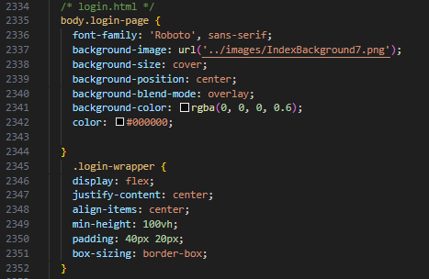

The login.html page is designed with the same structural and stylistic consistency as the form-based pages like joinus.html and membership.html. It features a visually engaging top banner area and a clean, centered login form below. The form is wrapped inside a container with the class login-form, which ensures consistent spacing, padding, and alignment across devices. This form includes fields for **username/email** and **password**, both styled with rounded corners and appropriate input types. The login button is prominently displayed beneath the input fields and vertically aligned to follow the visual pattern used throughout the site. The background uses a matching hero image or graphic that reflects the Brew & Go branding, contributing to an engaging yet professional interface. HTML5 validation ensures all fields are filled before submission, and the overall experience remains cohesive and accessible for users logging into the system.

## Profile Page

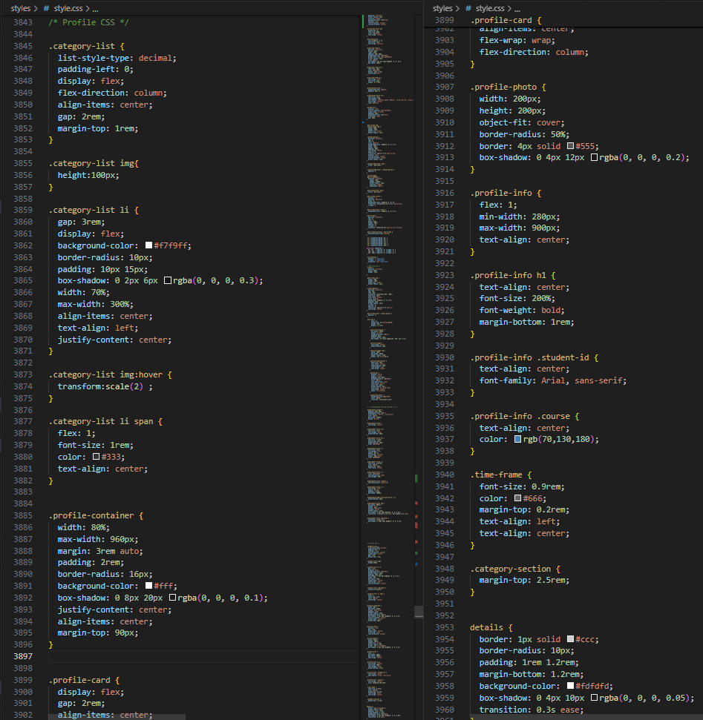

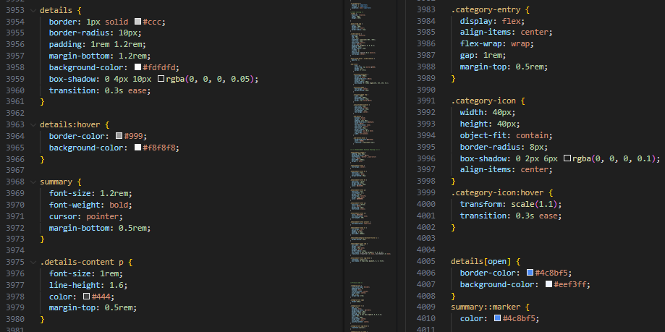

The profile page layout is meticulously structured using multiple CSS components to achieve a centered, clean, and responsive design. It begins with .profile-container, which sets the maximum width to 960px and centers the content both horizontally and vertically using margin: 3rem auto and align-items: center. This container is visually separated using a white background with a soft box-shadow to enhance readability and visual focus. Inside the container, .profile-card uses a flexible column layout to stack profile photo and details. The .profile-photo class sets a circular image frame using border-radius: 50% along with a subtle shadow effect. Beside it, .profile-info contains textual elements like the user’s name (h1), student ID, and course, all center-aligned and styled with varying font weights and colors to differentiate hierarchy and function.

Moving below the profile header, the .category-section introduces organized sections of categorized information using lists and interactive <details> blocks. The .category-list employs flex-direction: column and displays list items (li) in a card-like manner, each with a shadow and background color (#f9f9ff) for a soft, modern touch. Each list item scales slightly on hover, adding a responsive feel. Inside these list items, <span> tags are used for titles, and embedded <img> elements ensure iconography or illustrative support.

The <details> and <summary> elements are styled to resemble collapsible FAQ-style cards. The container itself has padding, rounded corners, and a light background (#fdfdfd). On hover, it subtly changes color and shadow for a dynamic interaction cue. When expanded, the [open] attribute changes border and background colors for clear visibility. Typography across the section is balanced with appropriate sizing (1.2rem for summary, 1rem for paragraphs), line heights, and muted tones (#666, #444) to ensure readability.

Finally, .category-entry and .category-icon contribute to a responsive icon grid section. Icons are rounded, visually elevated with shadows, and slightly scale on hover using transform and transition properties. The result is a profile page that feels personal, interactive, and well-structured — reflecting both aesthetic and usability principles in modern UI design.

## Enhancements

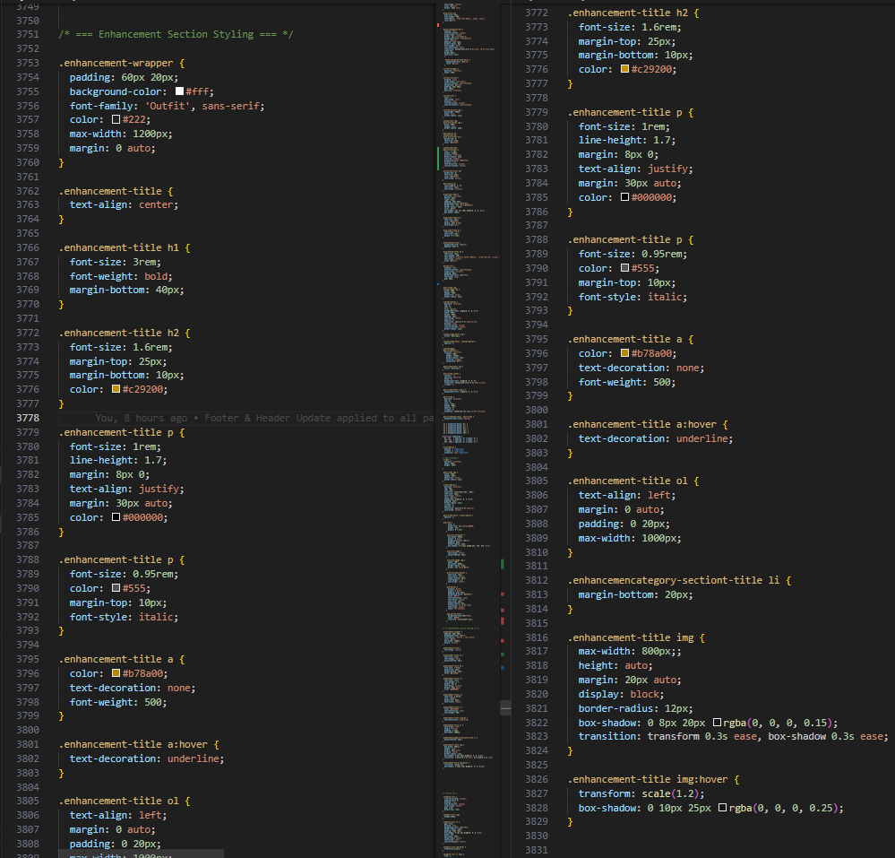

The **Website Style** section focuses on the overall aesthetics, consistency, and branding experience of the Brew & Go website. Through custom CSS and layout design, we aimed to deliver a visually appealing, modern, and user-friendly interface that reflects the identity of a premium coffee brand.

**✦ Custom Typography & Color Scheme**

We utilized the **Outfit** and **Roboto** fonts via Google Fonts to create a clean, contemporary look. These fonts were selected to ensure high readability while projecting a modern café identity. The color scheme (black, white, golden yellow, and accent blues) was carefully chosen to maintain harmony across all pages while drawing attention to interactive elements like buttons and hover states.

**✦ Consistent Layout with Reusable CSS**

Each page of the website uses a consistent grid layout defined in style.css. Classes such as .navbar, .footer, .product-page, and .blog-page allow uniform styling across various sections. This consistency improves user navigation and visual coherence.

**✦ Responsive Design with Media Queries**

Media queries were implemented to ensure the site adapts to different screen sizes, particularly for mobile and tablet devices. Elements such as the hamburger menu, stacked buttons, and scaled images maintain usability on devices ranging from desktops to phones.

**✦ Hover Effects for Interactivity**

Subtle hover effects were applied across navigation links, buttons, product cards, and activity slides. These include **scaling, shadow expansion, and color changes**, enhancing the interactive experience without overwhelming the user.

**✦ Semantic HTML and Accessibility**

Semantic HTML elements such as <section>, <nav>, <footer>, <ol>, and <details> were used to provide structure and meaning to the content. This improves accessibility for users using screen readers and also helps with SEO.

# Key Features (Enhancements)

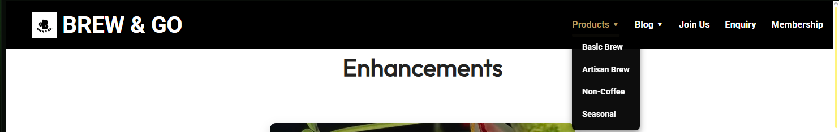

## Navbar

The navigation bar is implemented on all pages of the site and includes multiple enhancements. The most prominent are the dropdown content lists under “Products” and “Blog”, which become visible upon hovering. Additionally, all navbar items change color from white to golden-yellow and are underlined when hovered over, providing immediate visual feedback and improving navigation clarity.



## Shopping Cart

A floating shopping cart is integrated into every page, allowing users to access their selected items conveniently. When products are added, they remain visible even as the user navigates to different pages. The cart opens upon clicking the cart icon and closes when the close button is clicked or the icon is pressed again. This enhances the e-commerce functionality without disrupting the user experience.

## Mobile View

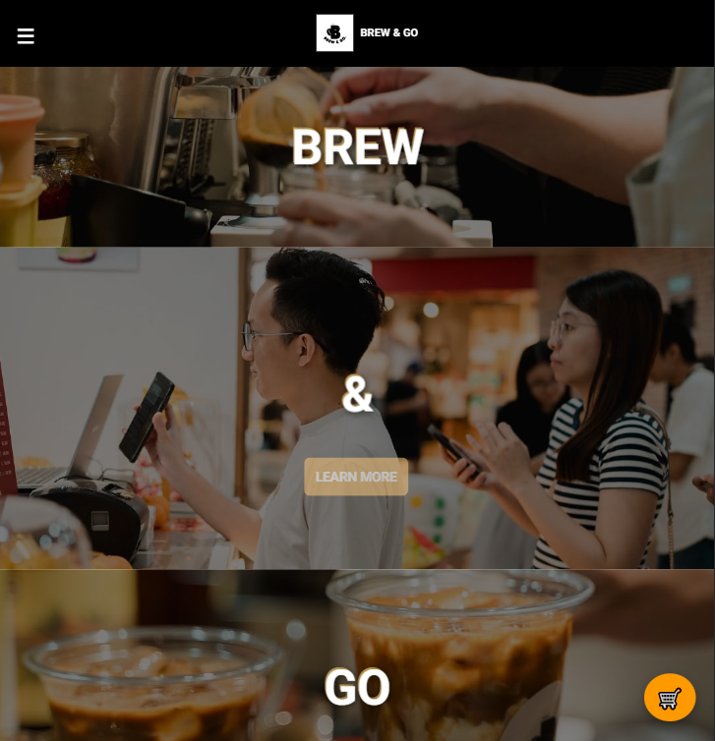

Responsive design techniques have been applied throughout the website. When viewed on mobile devices or tablets, the layout automatically adjusts for optimal readability. A hamburger icon replaces the full navbar on smaller screens. Tapping it reveals an overlay menu, ensuring seamless mobile navigation while preserving aesthetic consistency.

## Footer

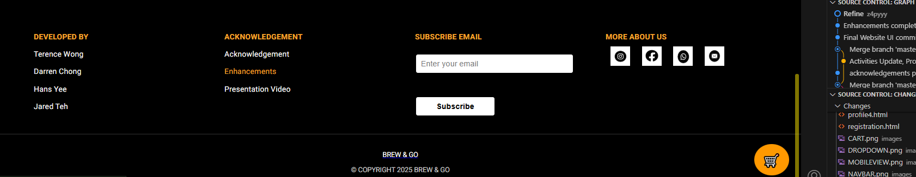

The footer contains its own hover enhancements. When users hover over the footer links, the text smoothly transitions from white to a soft yellow tone. This subtle effect gives visual indication of interactivity without overpowering the minimalist design.

## Carousel Section

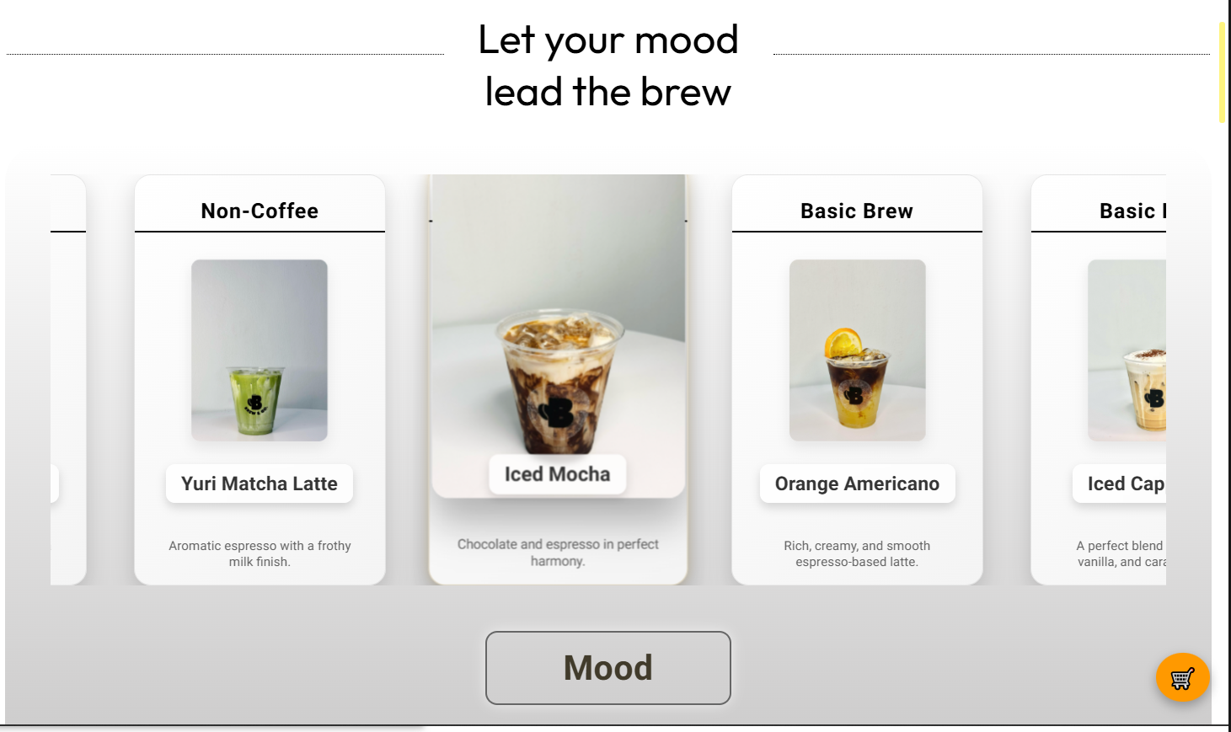

The homepage includes an auto-scrolling carousel showcasing featured items. It scrolls horizontally through the products and pauses when the user hovers over an item. On hover, the item enlarges and the shadow becomes more prominent, directing the user’s focus without requiring clicks or navigation.

## Membership Flip Cards

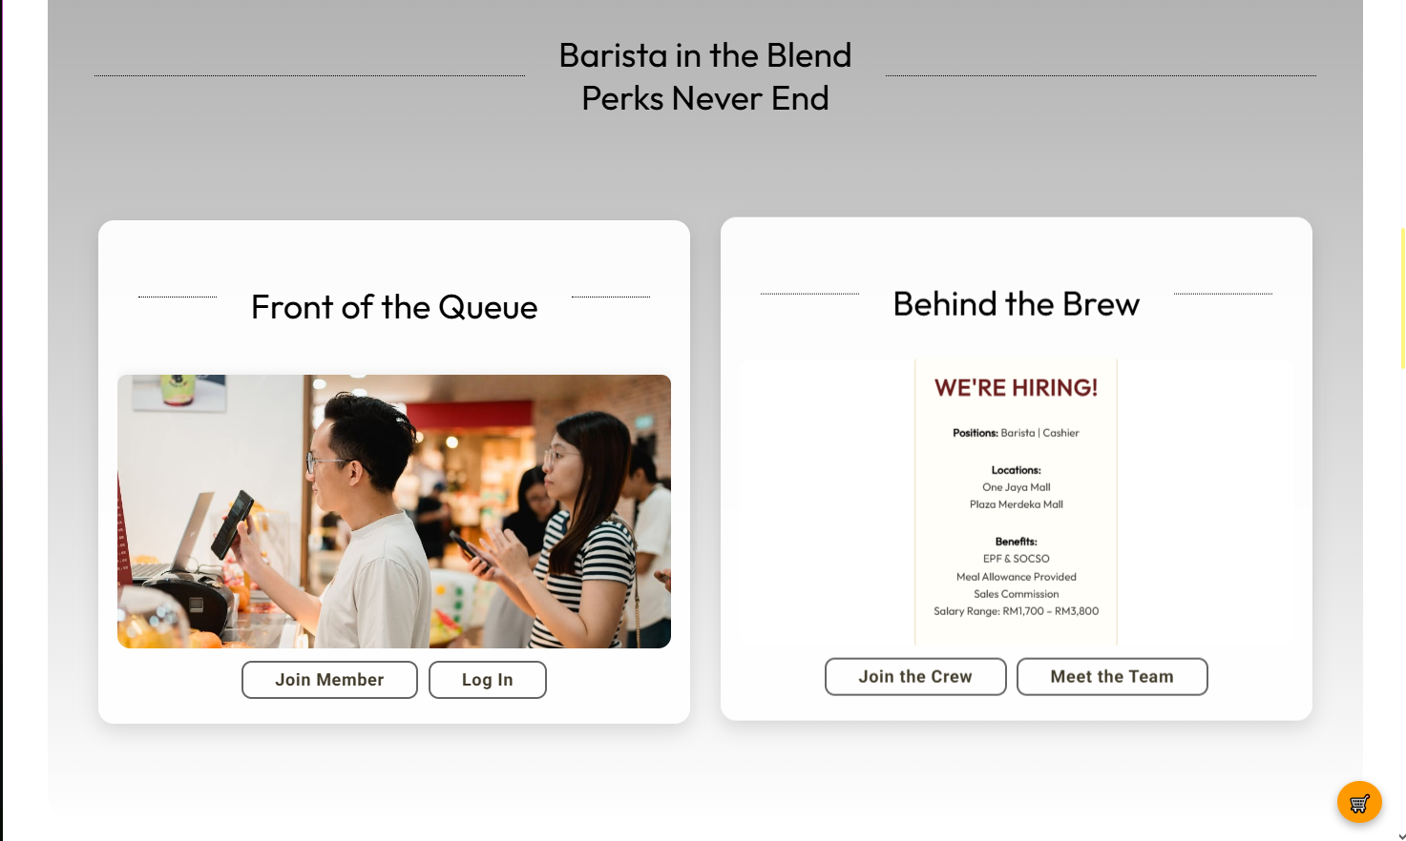

On the membership page, two distinct hover interactions are used. The main membership section features flip cards that reveal additional information on hover. The perks section includes five cards that expand on hover and reveal hidden text, encouraging exploration. These dynamic transitions make the membership benefits more engaging and user-friendly.

## Interactive Map

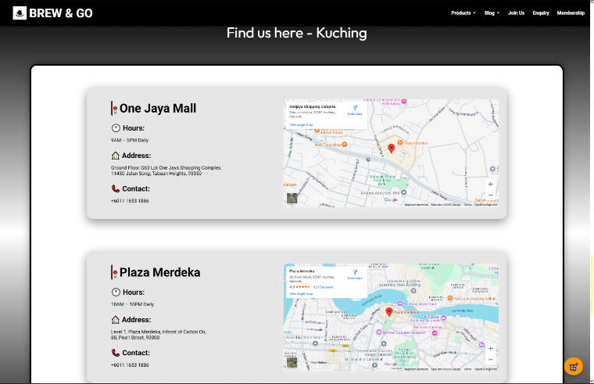

A dual Google Maps integration provides a practical enhancement. Located on the homepage, these maps display Brew & Go outlet locations. Users can zoom, switch to satellite view, and pan across the map using mouse or touch gestures. This functionality enhances credibility and accessibility.

## Looping Videos

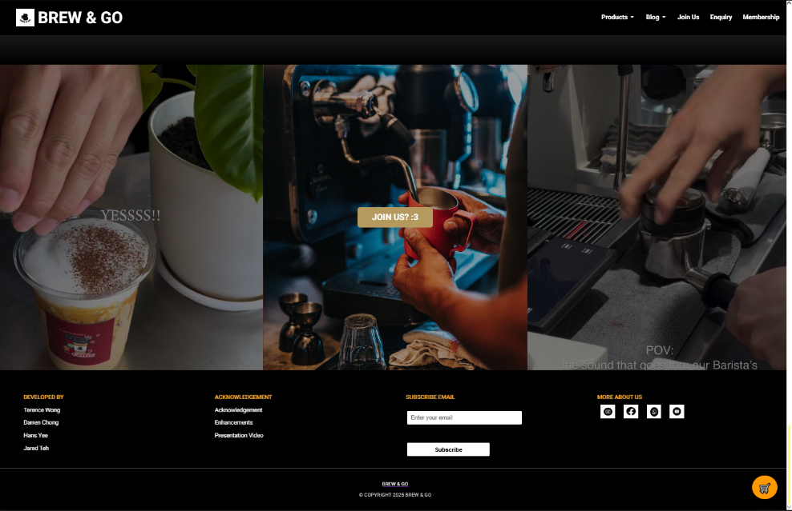

Two looping videos are placed at the bottom of the index page, flanking the “Join Us” call-to-action. These videos play continuously to enrich the aesthetic and branding appeal of the site, subtly adding motion and keeping the design visually dynamic without user interaction.

## Category Sidebar Hover

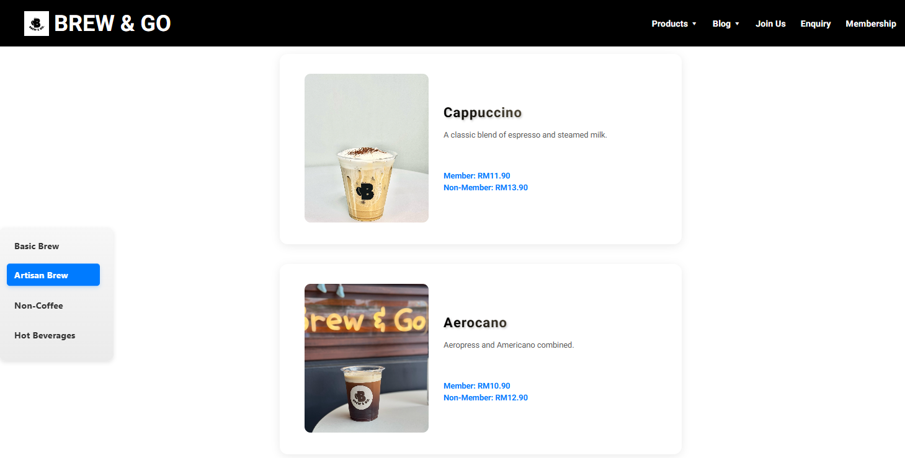

On the product pages, the sidebar includes hover-sensitive category buttons. Hovering over any category highlights it in blue and changes the text color to white. Additionally, product cards respond to hover by lifting slightly and enlarging their image, encouraging user interaction with a responsive and modern feel.

## Slideshow

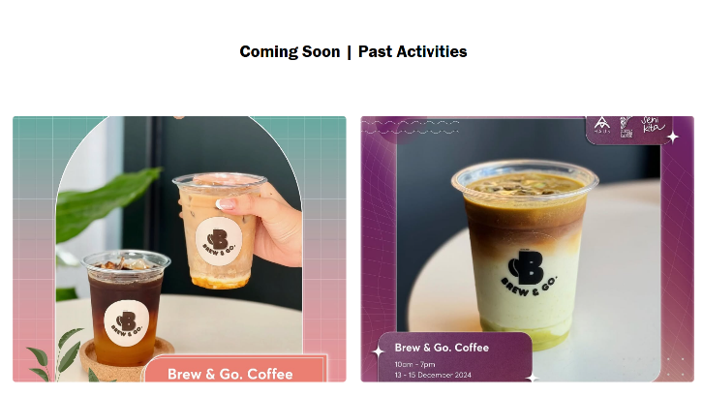

The Blog page includes a slideshow under the Past Activities section. This slideshow cycles through previous events and promotions, with clickable slides that lead to the full Past Activities page. This dynamic element keeps content visually fresh and interactive.

## Blog Hover Effects

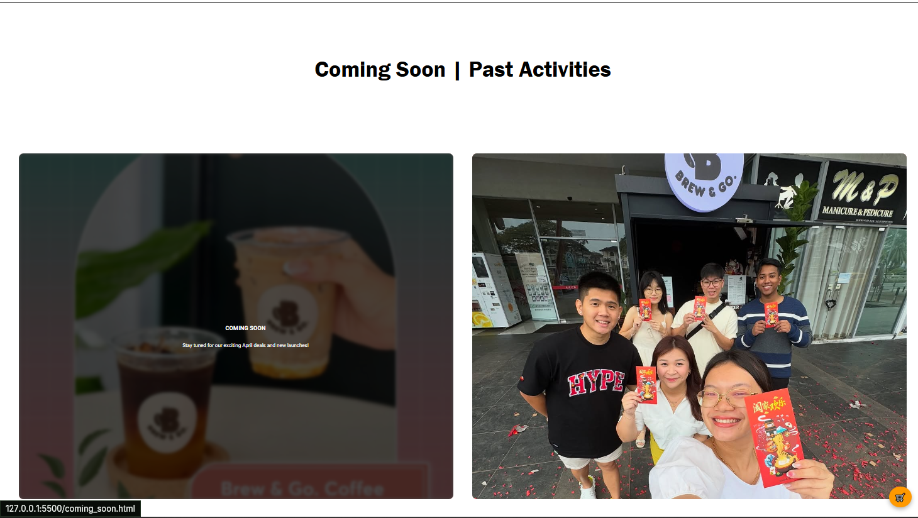

Slides and cards under the “Coming Soon” and “Past Activities” sections use hover effects to display additional information such as event dates and summaries. This ensures compact display while allowing users to learn more with minimal effort.

## Profile Page Cards

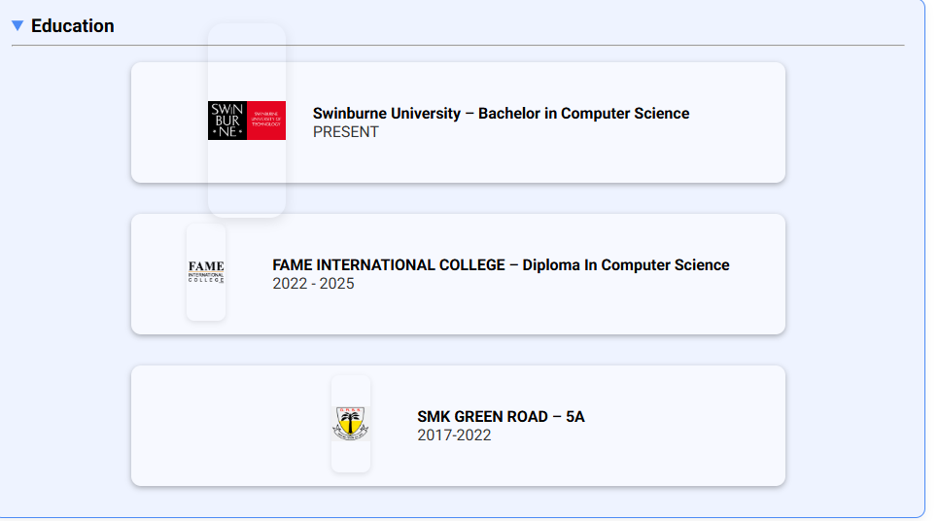

The profile page adopts a clean, card-based layout that organizes personal information into collapsible sections. Categories such as experience, education, and achievements are placed into <details> blocks for better readability. Logos beside entries are interactive: they scale up on hover and link directly to official organization websites (e.g., Swinburne, VEEKS, FAME), enhancing usability while maintaining professional structure.

# Conclusion

This project involved the development of a multi-page website for **Brew & Go**, showcasing products, membership programs, ongoing activities, and interactive content. The site was built using HTML and CSS only, following semantic and responsive design principles. Pages such as index.html, product1~4.html, joinus.html, enquiry.html, membership.html, and profile1.html were carefully structured to ensure consistency in branding and usability. Key features implemented include a mobile-responsive navigation bar, animated carousel, collapsible content cards, embedded Google Maps, membership flip cards, and various hover-based enhancements.

Throughout the development process, we gained hands-on experience with layout design, media responsiveness, semantic structuring, and user interface interactivity—all while working within the limitations of HTML and CSS. This exercise not only strengthened our frontend design skills but also reinforced the importance of accessibility and user experience design.

## Future Improvements and Recommendations:

1. **Cleaner and More Modular Codebase**:

Refactoring the code to improve naming conventions, segment reusable styles, and reduce redundancy would make the project more scalable and easier for future collaboration.

1. **JavaScript Integration**

With JavaScript, we can greatly enhance interactivity. For example, making the embedded map clickable with real-time location filtering or allowing users to interact with dynamic form validation and animations would elevate the user experience.

1. **Expanded Media Queries for Diverse Devices**

While the current responsive layout works well for common screen sizes, introducing more @media breakpoints (e.g., for tablets, ultra-wide monitors, or foldable phones) would ensure an even more seamless experience across a wider range of devices.

1. **Backend Implementation**:

Introducing a backend (e.g., using PHP, Node.js, or Firebase) could allow for persistent data storage, user authentication, dynamic product listings, and admin content management—transforming this static website into a fully functional web application.

1. **Framework Usage**:

Future iterations could benefit from adopting frontend frameworks like Bootstrap or Tailwind CSS for faster styling, or even React.js or Laravel for modular component-based development to enhance maintainability and performance.

Looking back, I feel there’s still much more that could be achieved. This project was a meaningful step forward, and I’m proud of what we’ve built—but I also look forward to future opportunities where I can push the boundaries even further, refine my skills, and deliver something even better.